  FLEXIBLE DISPLAY CENTER | Document Owner:  Dirk Bottesch | Release Date:  31-Aug-06
Document Title:  MRC603-1 , 2 | Document No: FDC-OP-0089 | Document Rev: 02  Oct-22-09 db/vw

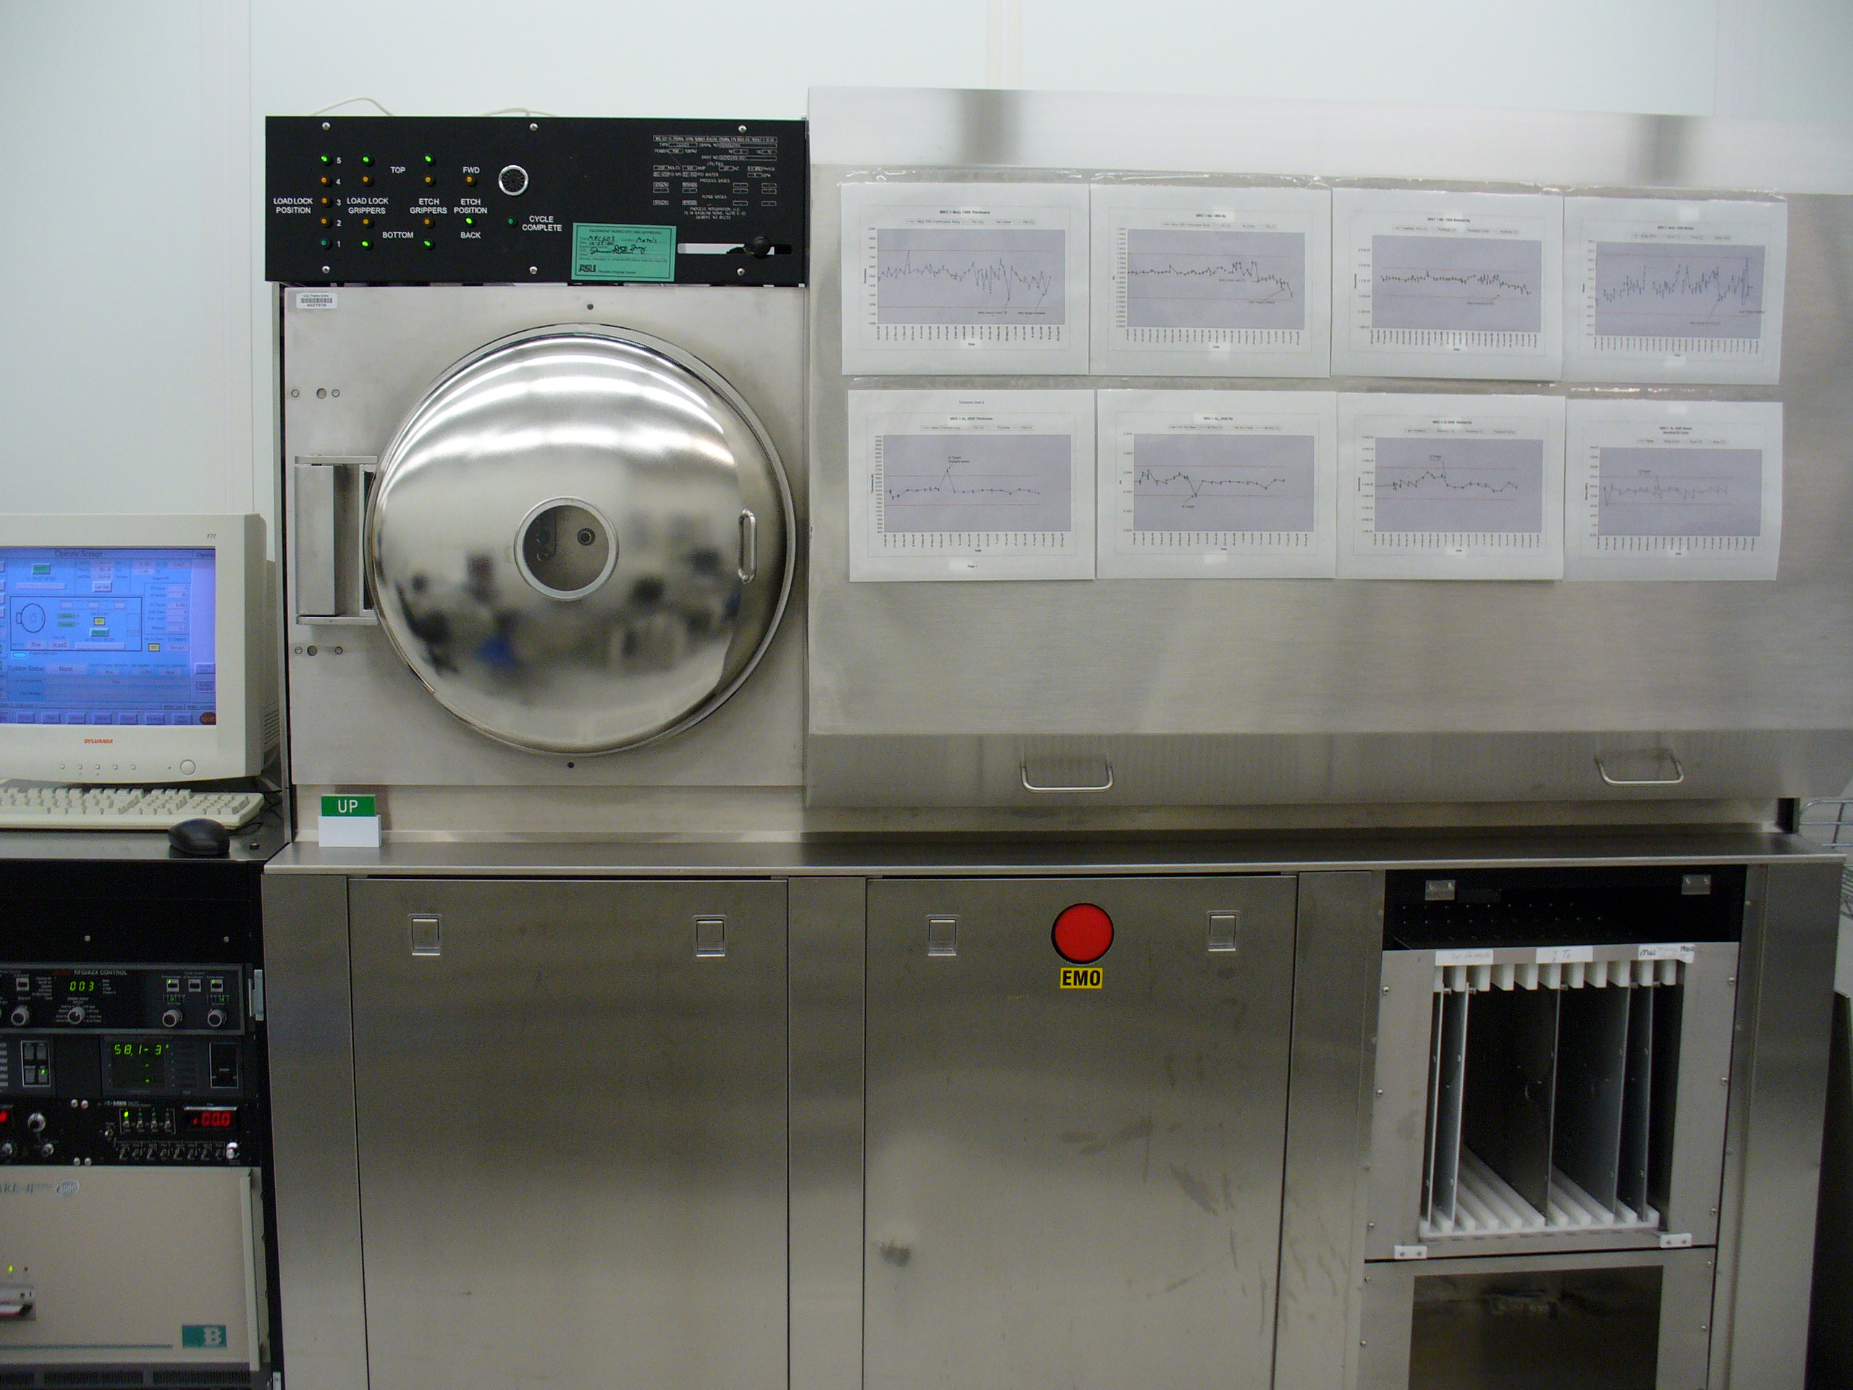
MRC 603-1 Mr. T

SPECIFICATION FORMAT:
EQUIPMENT MANUFACTURER: |  | Materials Research Corporation (MRC)
EQUIPMENT MODEL: |  | MRC-603-1 (Mr.T) MRC-603-2 (King Kong)
FDC ASSIGNED TOOL ID NUMBER: |  |  | MRC-603-1 (Mr.T)—ASU 4027518  MRC-603-2 (King Kong) –ASU 4027557
APPLICATION PROGRAM(S) AND REVISION: |  |  |  | Microsoft Word 2003
MRC-603-1 (Mr.T) 1998 Brooks Automation Software Version 2.1
MRC-603-2 (King Kong) Brooks Automation Software Version 2.10b

SIGNATURES FOR RELEASE OR HISTORY ON FILE IN PRODUCT SPECIFICATIONS |  |  |  | Confidential Proprietary
ORIGINATOR:  Dirk Bottesch/ Virginia Woolf |  |  |  | The information contained in this document is the property of the Flexible Display Center at Arizona State University. No information contained in this document may be disclosed outside of the Flexible Display Center at Arizona State University at any time.
RESPONSIBLE ENGINEER:
Dirk Bottesch
DIRECTOR OF OPERATIONS:
Shawn O’Rourke

Table of Contents
1.1 Definitions 4
1.2 Documents and Manuals Referenced 4
2.0 EQUIPMENT AND SUPPLIES 4
2.1 Test Equipment 4
2.2 Standard Product + Supplies 5
2.3 Parts and Consumables List (Supplier Information) 5
3.0 SAFETY 5
3.1 FDC-OP-0001 Clean Room Protocol 5
4.0 PROCEDURES 6
4.1 Log into MRC Operations Computer 6
4.2 Operating Procedures loading a pallet. 6
4.3 Operating Procedures removing a pallet. (See Figure 1) 7
4.4 Selecting a Program (see Minispec Attachments 1-10 for programs) 8
4.5 Documentation 9
4.6 Weekly Qualification 12
5.0 Routine Maintenance 13
5.1 Cryo Pump Regeneration 13
5.2 Pallet Maintenance ………………..… .. 14Error! Bookmark not defined.
5.3 Daily Initialization……………………………………………………………………………………...14
5.4 Etch Gripper Alarm With A Pallet………………………………………………...................................14
5.5 Computer Restart Procedure…………………………………………………………………………….15
5.6 System Power Restart Procedure (EMO, Power, Failure, etc.)…………………………………………15

.

List of Figures

Figure 1 …………………………………………………………………………………………5
Figure 2 …………………………………………………………………………………………6
Figure 3 7
Figure 4 ...………………………………………………………………………………………..8
Figure 5…………………………………………………………………………………………..8
Figure 6…………………………………………………………………………………………11
Figure 7…………………………………………………………………………………………11

SCOPE

Definitions

Substrates: Target material for depositions.

Pallet: Stainless Steel carrier for substrate.

Dome: Door for loading and unloading of pallets.

Sputter etch: RF etching of the substrates.

Sputter Deposition: Deposition of material (metal/dielectrics) by DC/Pulse power DC/RF powering the target material in an Argon/Ar/02 environment.

Documents and Manuals Referenced

Minispec Recipe Book

EQUIPMENT AND SUPPLIES

Test Equipment

Tencor Flex Gauge

Ambios Thin Film Profilometer

Automatic Four Point Probe

Standard Product + Supplies

3000A Oxide coated 150 mm silicon wafers (new).

Parts and Consumables List (Supplier Information)

Facilities Argon gas.

Facilities Oxygen Gas (not used on MRC 603-1 “Mr.T”).

SAFETY

FDC-OP-0001 Clean Room Protocol

This system uses 120v AC and 13.56 MHz RF. Make sure all covers and interlocks are in place, and in working order. Never operate the tool with covers knowingly off or interlocks jumpered. Contact the process engineer for issues and questions.

PROCEDURES

Log into MRC Operations Computer

In order to log into operate the MRC Operations Computer, select <login> on the computer screen. A screen keyboard will show onscreen. Use it or the manual keyboard and type <maint> in small letters for the USER and hit <ENTER>. The screen will fill in the Level to be Maintain. At this time, select <OK> to enter the system.

Operating Procedures loading a pallet.

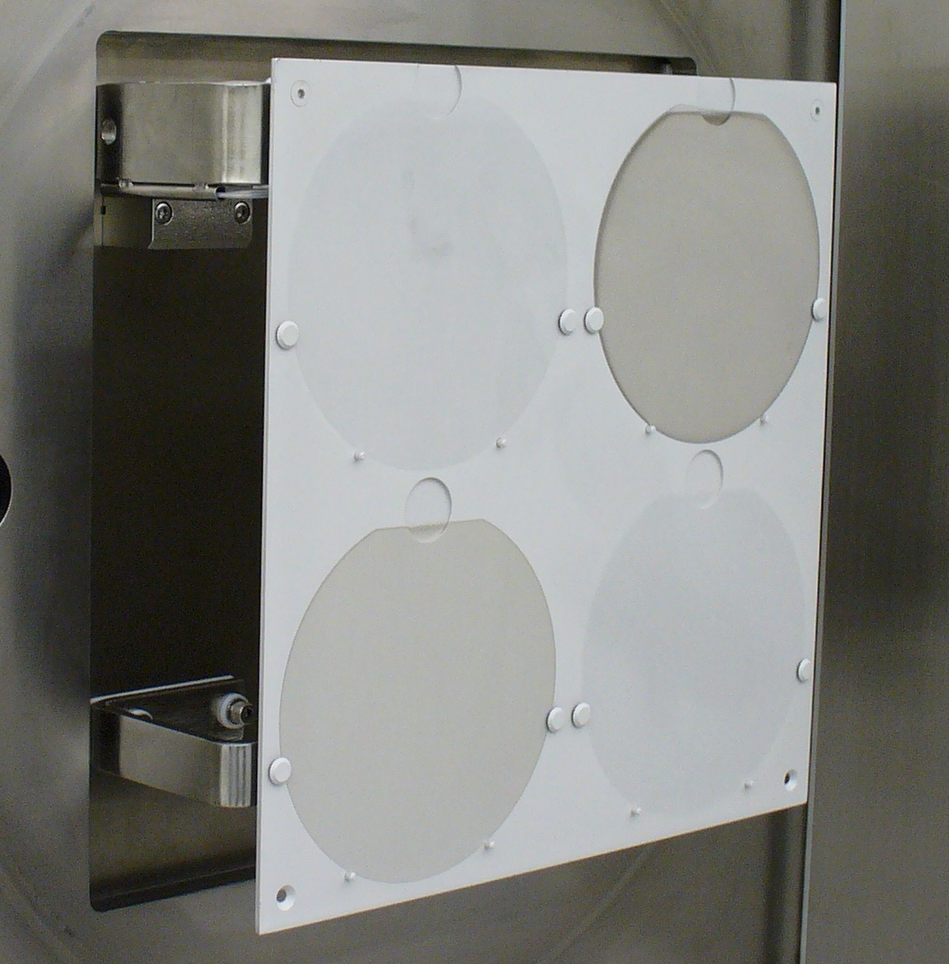

Figure 1

Vent the dome by directing the mouse to the <vent> button on the Operate screen and clicking the mouse button once. Dome is vented within 5-7 minutes.

Open the dome.

Load the pallet by hanging the pallet buttons in the matching notches on the front loading arm inside the dome.

Select the program (See 4.4) (Figure 1)

Close the dome and wait for vacuum seal.

Operating Procedures removing a pallet. (See Figure 2)

After the completion of any run, the last step in the process will automatically vent the dome with the completed pallet within.

Open the dome.

Unload the pallet by grabbing the pallet on both sides between the front loading arm, and the front support. Lift it off the notches on the rear loading arm high enough to clear the front lower support.

Tilt the bottom of the pallet out, and over the front lower support arm without hitting anything.

Follow the tilt angle of pallet over the front lower support arm and under the front loading arm.

. 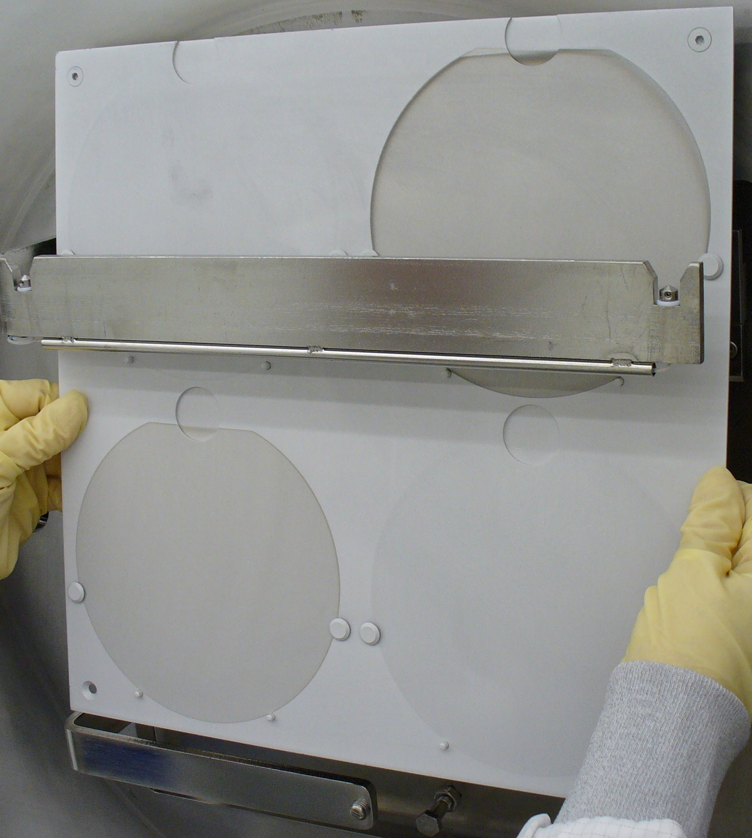
Figure 2

Selecting a Program (See the Minispec Recipe Book)

Open the MRC computer screen to the operate page by selecting<operate> at the bottom of the computer screen.

Select the <LL pallet recipe> gray bar in the upper left of the computer screen with the mouse by clicking on the bar.

Once the program bar is selected, the program screen will automatically open with
program selections.

Verify the Lot Traveler and/or the MES System for the process to run. (See MES Operations Specification for procedures)

Select the desired program to run and click OK.

The recipe will come up of the process selected.

Verify the recipe conditions on the computer (See the Minispec Recipe Book).

Select resume on the bottom right of the screen to return to the operate screen.

With the pallet of material loaded on the load station of the loadlock, close the dome and
hold until the loadlock pumpdown valve opens and seals the dome. (3-5 sec)

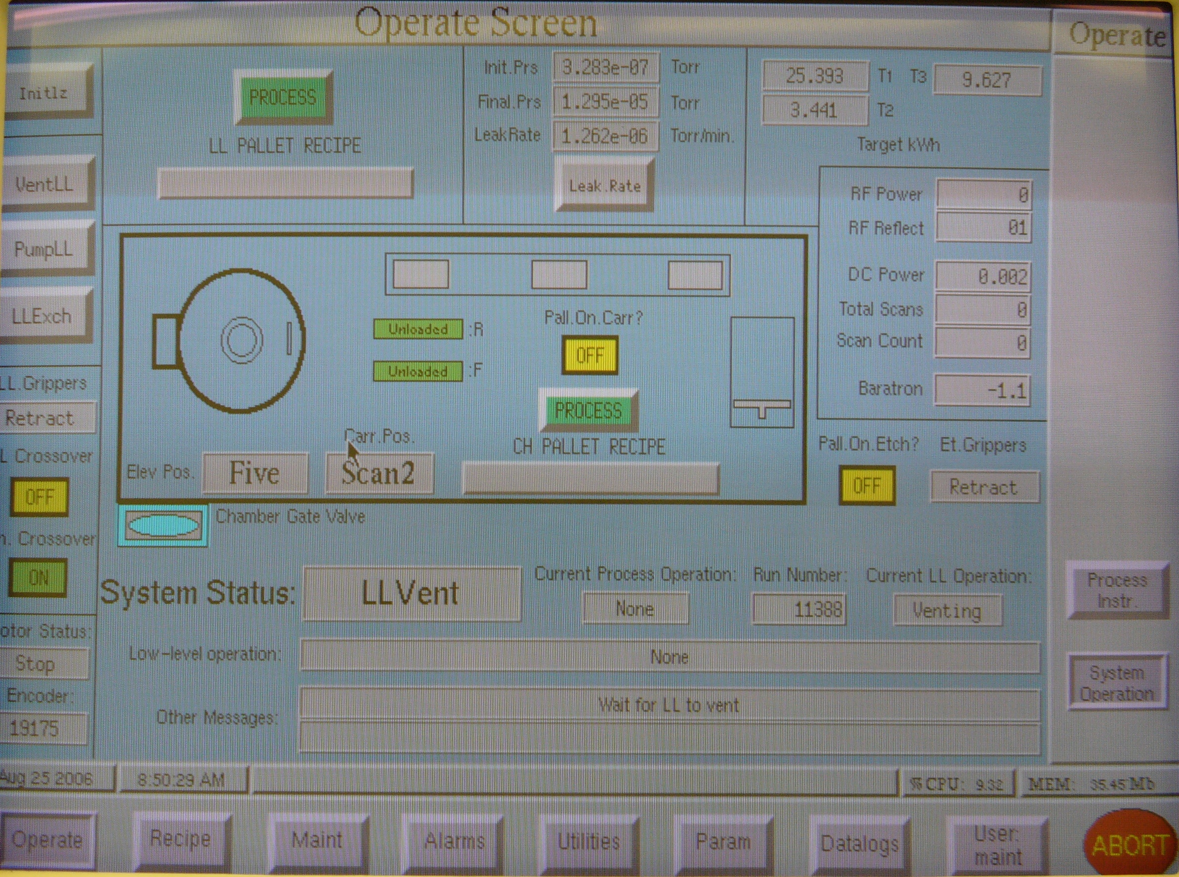

Figure 3

Documentation

Before starting a lot, take the traveler to the MES System and log into MES. (See MES Operations Specification for procedures) Verify that the lot is at the correct operation and select <Start Equipment>.

After completing the lot on the MRC, log into MES and select <Stop Equipment>.

Log on to any computer with sever access and select <My Computer/Operations on File Server01(fdcsrvfs01) (Q:)/Metals/MRC/(Mr.T or King Kong)/603 run log (Mr.T or King

Kong).xls opening the Excel MRC Log Sheet.

Fill in the information on the log sheet; date, lot number, operator, number of wafers, and recipe. The sputter etch data is located at the RFG/AZX CONTROL. (See Figure 4) Record the reflected power, and the DC Bias. The pressure and flow data is located at the MKS Instrument Controller. (See Figure 4) Record the pressure, (right) flow (left).
4.5.5 Record the voltage and current located at the Pinnacle left displays. (See Figure 5)

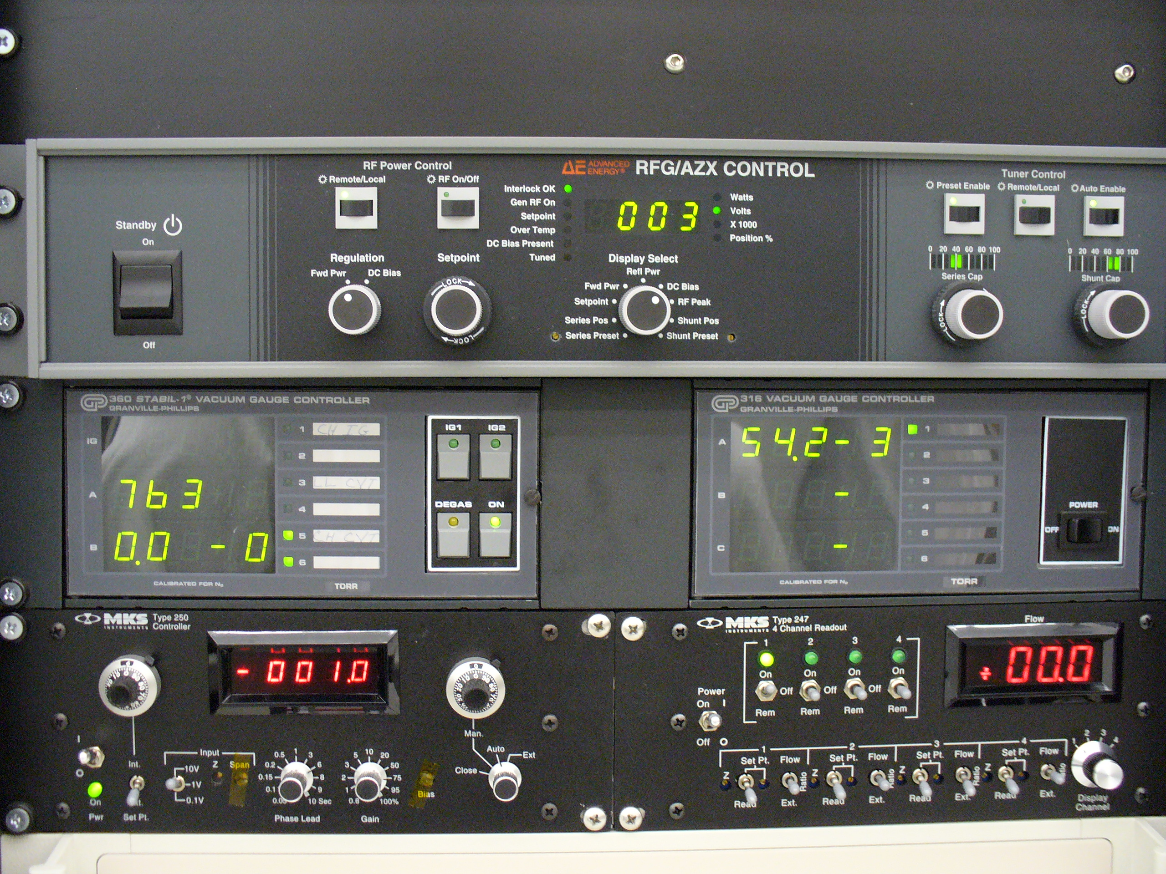
Figure 4

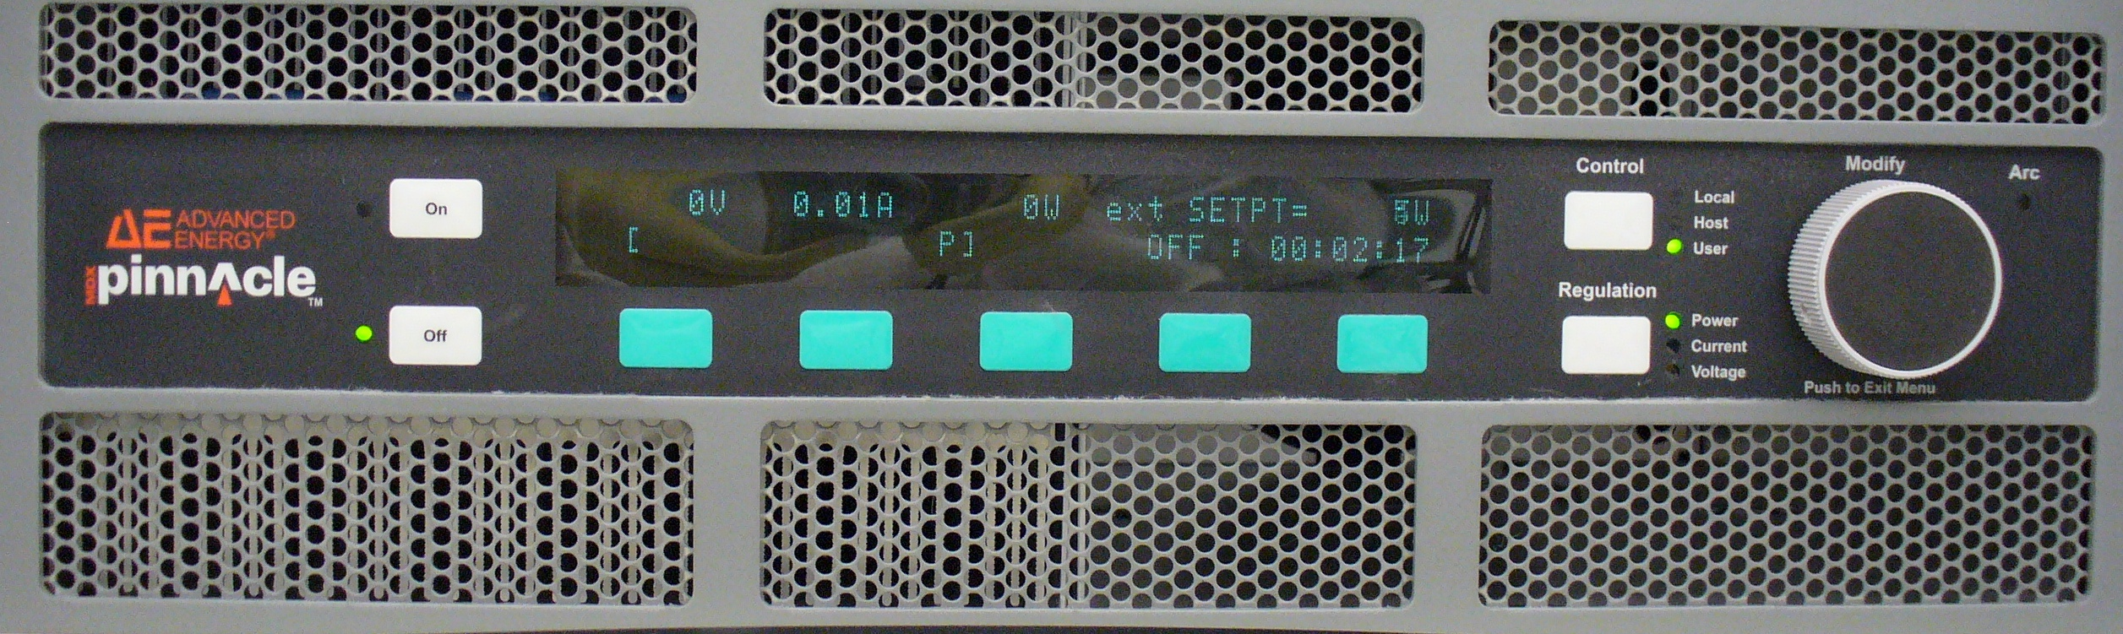

Figure 5

Weekly Qualification

At the beginning of the work week use the document; Metals Weekly Check List. Record the results in the <My Computer/Operations on File Server01 (fdcsrvfs01) (Q:)/Metals/ Metals Weekly Check Lists>

The operation screen (Figure 3) displays the leak rate test. Click on the grey Leak Rate box to begin the leak rate test. Record the results in the <My Computer/Operations on File Server01 (fdcsrvfs01) (Q:)/Metals/MRC/(Mr.T) MRC vacuum tests Mr.T LeakRates>

The operation screen (See Figure 3) displays the tool functions on the upper left side of the screen. The first box is Initlz (Initialization). This operation checks the function of the carrier, grippers, and etch platform. The message Init completed will be displayed when this function is done. The second box is Vent LL (Vent loadlock). This function will vent the loadlock to atmosphere, allowing the door to open. The third box is PumpLL (pump loadlock). This function with the door closed, pumps the loadlock until the desired vacuum is reached. The fourth box is LLExch (Loadlock Exchange). This function allows the removal of pallets from inside the chamber.

Load a pallet (See 4.2 and Figure 1) using position two and three (Pallet Position Upper Right and Lower Left) with particle wafers. Vent the loadlock, load the pallet on the hanger, and hold the door closed while selecting the PumpLL. Select the LL PALLET RECIPE, select the Particle program, and then click OK. Record the results in the <My Computer/Operations on File Server01 (fdcsrvfs01) (Q:)/Metals/MRC/(Mr.T) Mr.T T Particle Test>

Use the Aluminum pallet, load the etch rate wafers in position two and three. Load the pallet on the hanger, select the RF Etch program to process the etch rate. Record the results in the <My Computer/Operations on File Server01 (fdcsrvfs01) (Q:)/Metals/MRC/(Mr.T) Mr.T T Etch Rates>

Use the Aluminum pallet; load the Al_2000 wafers in position two and three. Load the pallet on the hanger, select the Al_2000 program to process the Al_2000 test. Record the results in the <My Computer/Operations on File Server01 (fdcsrvfs01) (Q:)/Metals/MRC/(Mr.T) Aluminum Al2000 Weekly Check>

Use the Molybdenum pallet; load the Moly_1500 wafers in position two and three. Load the pallet on the hanger, select the Moly_1500 program to process the Moly_1500 test. Record the results in the <My Computer/Operations on File Server01 (fdcsrvfs01 (Q:)/Metals/MRC/(Mr.T) Moly 1500 Weekly Test>

Reread all the wafers on the Tencor stress measurement tool, and four point probe. Record the results in the Aluminum, and or Moly Weekly Check.

Read the post etch wafers on the Ambios measurement tool. Record the thickness results in the Aluminum, and or Moly Weekly Check.

Read the Particle wafers on the Tencor particle tool. Record the results in the Aluminum, and or Moly Weekly Check.

Use the Aluminum pallet; use a thermal oxide wafer for the temperature test. Use Kapton tape to adhere the Reatec Temperature Indicator. Select the Al_2000 program to process the test. Record the results in the Aluminum Weekly Check.

Use the Molybdenum pallet; use a thermal oxide wafer for the temperature test. Use Kapton tape to adhere the Reatec Temperature Indicator. Select the Moly_1500 program to process the test. Record the results in the Moly_1500 Weekly Check.

Routine Maintenance

Cryo Pump Regeneration

Select the maintenance screen, using your mouse click on the blue cryo pump display. Select (CLSD) to close the gate valve. Open the cover labeled (ACCESS HERE FOR THE ON BOARD CRYO FUNCTIONS) to see the ON-BOARD screen. Select the number one, or two to start the cryo regeneration. (See Figure 6)

When the process is finished, complete an initialization of the system. (See 4.6.3 Figure 3)

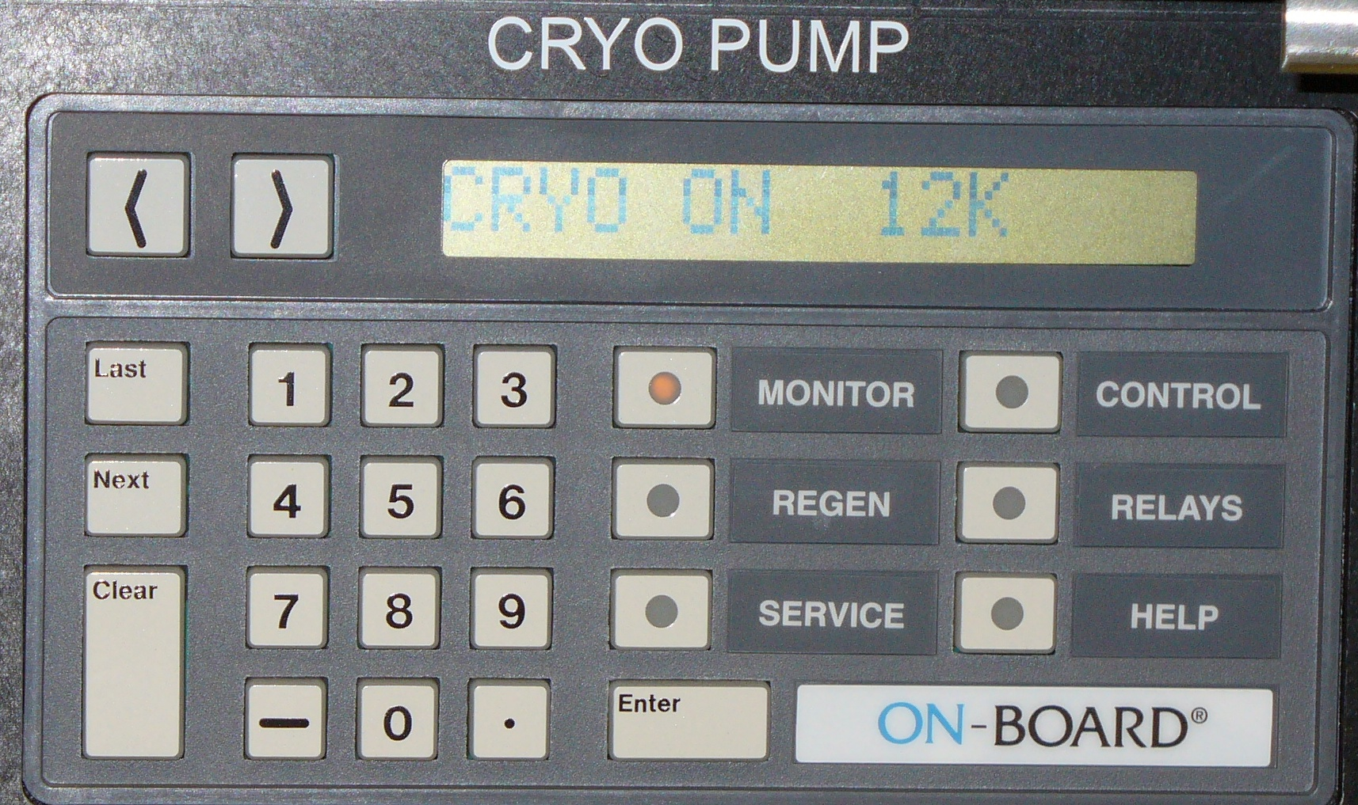
Figure 6

Pallet Maintenance

The pallets will be sent out for cleaning and repairs by engineering.

The clean or new pallets will need to be wiped down using clean room wipes and IPA.

ALL cleaned or new pallets will need to be coated using program Al_2000.

The pallets used for Moly will need to be coated using the program Moly_1500 after coating with Al_2000.

Daily Initialization

Go to the Operate Screen; use the mouse to left click on the upper left Initlz button.
5.3.2 If there is an etch gripper alarm, clear the alarm and run. This is a common error due

to computer timing. For any other error, contact Engineering.
5.3.3 Return to the Operate Screen and repeat the initialization procedure.
5.3.4 Complete this procedure before operating the tool everyday.

Etch Gripper Alarm with A Pallet
5.4.1 Clear the alarm, run and acknowledge the resume button which will come up on the Process
Instr. Page behind the Operate Page. This button does not restart any operation on the tool

but is required to be cleared.
    - Open the door at the etch station; turn the viewport handle clockwise to see the pallet.
    - Verify that the pallet is in the etch station.
    - Repeat the initialization procedure.
    - Use a flashlight to observe the process of the pallet being loaded on to the carrier.
    - If the pallet is on the carrier reload the program and continue the process.
    - If the pallet dropped in the etch station, contact Engineering.

5.5 Computer Restart Procedure

    - Note the location of all pallets, elevator position, and carrier within the system.
    - Press the red reset button on the Techware II computer and wait for computer initialization.
    - The Blue User Identification screen login will display after a few minutes.
    - Use the mouse or keyboard to type<maint> for the user name, select<login>, select <ok>.
    - Initialize the system using the Daily Initialization procedure.
  - System Power Restart Procedure (EMO, Power Failure, etc)
    - Verify reason for power off has been addressed, ie EMO for water leak, etc.
    - Release EMO buttons if used for the shutdown. Follow twist arrow on red EMO button.
    - Open front panel cover where Cryo controller is located.
    - Press the green MAIN PWR OFF/ON BUTTON to start the system. If the system does not start, press the red RESET button to the right of the MANI PWR OFF/ON and then again the green MAIN PWR OFF/ON button. The tool should start.
    - Do not initialize tool.
    - Verify Cryo Regeneration has started. If not, then start Cryo Regen.
    - Upon completion of Cry Regen, note the location of the Pallet Carrier on the Encoder. The Encoder should be showing 19175.
      - If it is not, verify the condition of the tool when power was off. If the tool was not at
Idle or pallet carrier known to be at the start-scan 2 position at power off, then the tool must be vented to locate the pallet carrier for alignment.
      - If the pallet carrier was known to be at the start-scan 2 position at power off, either
Because it was idled or confirmed by operator at power off but the Encoder is showing zero, then the pallet carrier must be manually driven to the Encoder position -19175 (negative) and then the Encoder reset to zero using the Maintenance page. This may require the system to have the Master Interlock on the Maint I/O page disabled. After the Encoder, the operator, and pallet agree on the location, the Master Interlock must be re-enabled. The system may then be Initialized.
      - If the pallet carrier was known to be at the start-scan 2 position at power off, either
Because it was idled or confirmed by operator at power off, the Initialize the system.

