  FLEXIBLE DISPLAY CENTER | Document Owner:  Nick Munizza | Release Date:
Document Title:  Western Magnum Operating Procedure | Document No: | Document Rev: 01

SPECIFICATION FORMAT:
EQUIPMENT MANUFACTURER: |  |  | Western Magnum
EQUIPMENT MODEL: |  |  | XRL 180
FDC ASSIGNED TOOL ID NUMBER: |  |  | ASU Property Control # 4027554
APPLICATION PROGRAM(S) AND REVISION: |  |  | Microsoft Word 2003

SIGNATURES FOR RELEASE OR HISTORY ON FILE IN PRODUCT SPECIFICATIONS |  |  |  | Confidential Proprietary
ORIGINATOR:  Nick Munizza |  |  |  | The information contained in this document is the property of the Flexible Display Center at Arizona State University. No information contained in this document may not, be disclosed outside of the Flexible Electronics and Display Center at Arizona State University at any time.
RESPONSIBLE ENGINEER:
Emmett Howard
DIRECTOR OF OPERATIONS:

Table of Contents
1.0 Purpose 3
2.0 Scope 3
3.0 Associated Materials and Equipment 3
4.0 Safety 3
5.0 Procedures 3-5
6.0 Clean Up 4
7.0 Photo 5

Purpose
  - To define the operating procedures for the Western Magnum Laminator.

Scope

- Materials and Equipment
  - Western Magnum XRL180
  - 18” long Mylar strip
  - Carrier sheet.
  - Clean room wipes.
  - Timer.
  - Solvent.

- Safety

  - The Western Magnum Laminator has moving mechanical parts, keep fingers clear when the rollers are in motion.
- Procedures

  - Press the Power button to turn the laminator on.
  - To set the heat temperature:
    - There are two sets of controller. One for each of the roller.
    - Press the up / down arrow to set the desired set temperature.
  - To set the lamination speed (fpm):
    - Cut a sheet of Mylar to 18” in length.
    - Be sure to press the Drive button.
    - Make sure the air switch is set to the On position.
    - Adjust speed by turning the FPM (feet per minute) speed knob.
    - Locate a timer.
    - Place an 18” Mylar strip in front of the rollers.
    - Push the Mylar sheet until it makes contact between the rollers.
    - Start the timer. Do not adjust the speed at this time.
    - When the Mylar sheet has cleared the rollers, stop the timer.
    - Determine if the lamination speed needs adjusting.
    - Adjust the SPEED dial on the front panel (increase/decrease).
    - Repeat steps 5.3.6 – 5.3.11 until desired speed achieved.
    - You may have to do several runs in order to get the required FPM.
    - Run product once the SPEED is set.
- Pressure adjustment
  - Pressure adjustment dial and pressure indicator are located on the side of equipment
- Procedure to turn off the Laminator
  - Press Heat button (light off).
  - Press Drive button (light off).
  - Press Power button (light off).
- Clean up

NOTE: Before starting, be sure that the rollers are at room temperature.
  - If any material has made contact with the rollers, you will need to use the appropriate solvent in order to remove it.
  - Press the Air Switch to the Off position.
  - Press the Power button on.
  - Press the Drive button on.
  - If the rollers are not rotating, then turn the speed dial until the rollers start to rotate.
  - Wipe the rollers with a cleanroom wipe and solvent.
  - When Cleanup is Completed
    - Press the Power button off.
    - Press the Drive button off.
    - Press the Air Switch back to the on position.

- Photos

Western Magnum 180
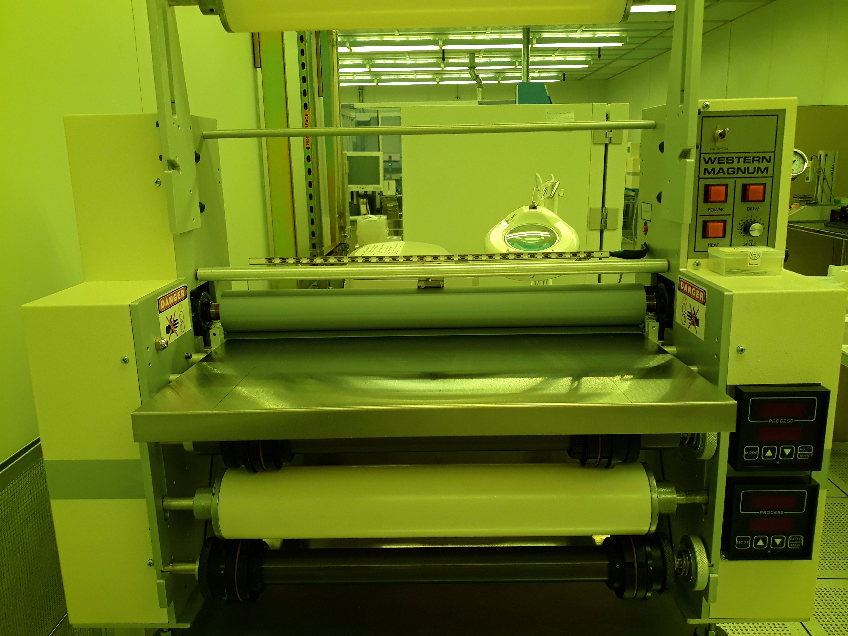

Front Control Panel
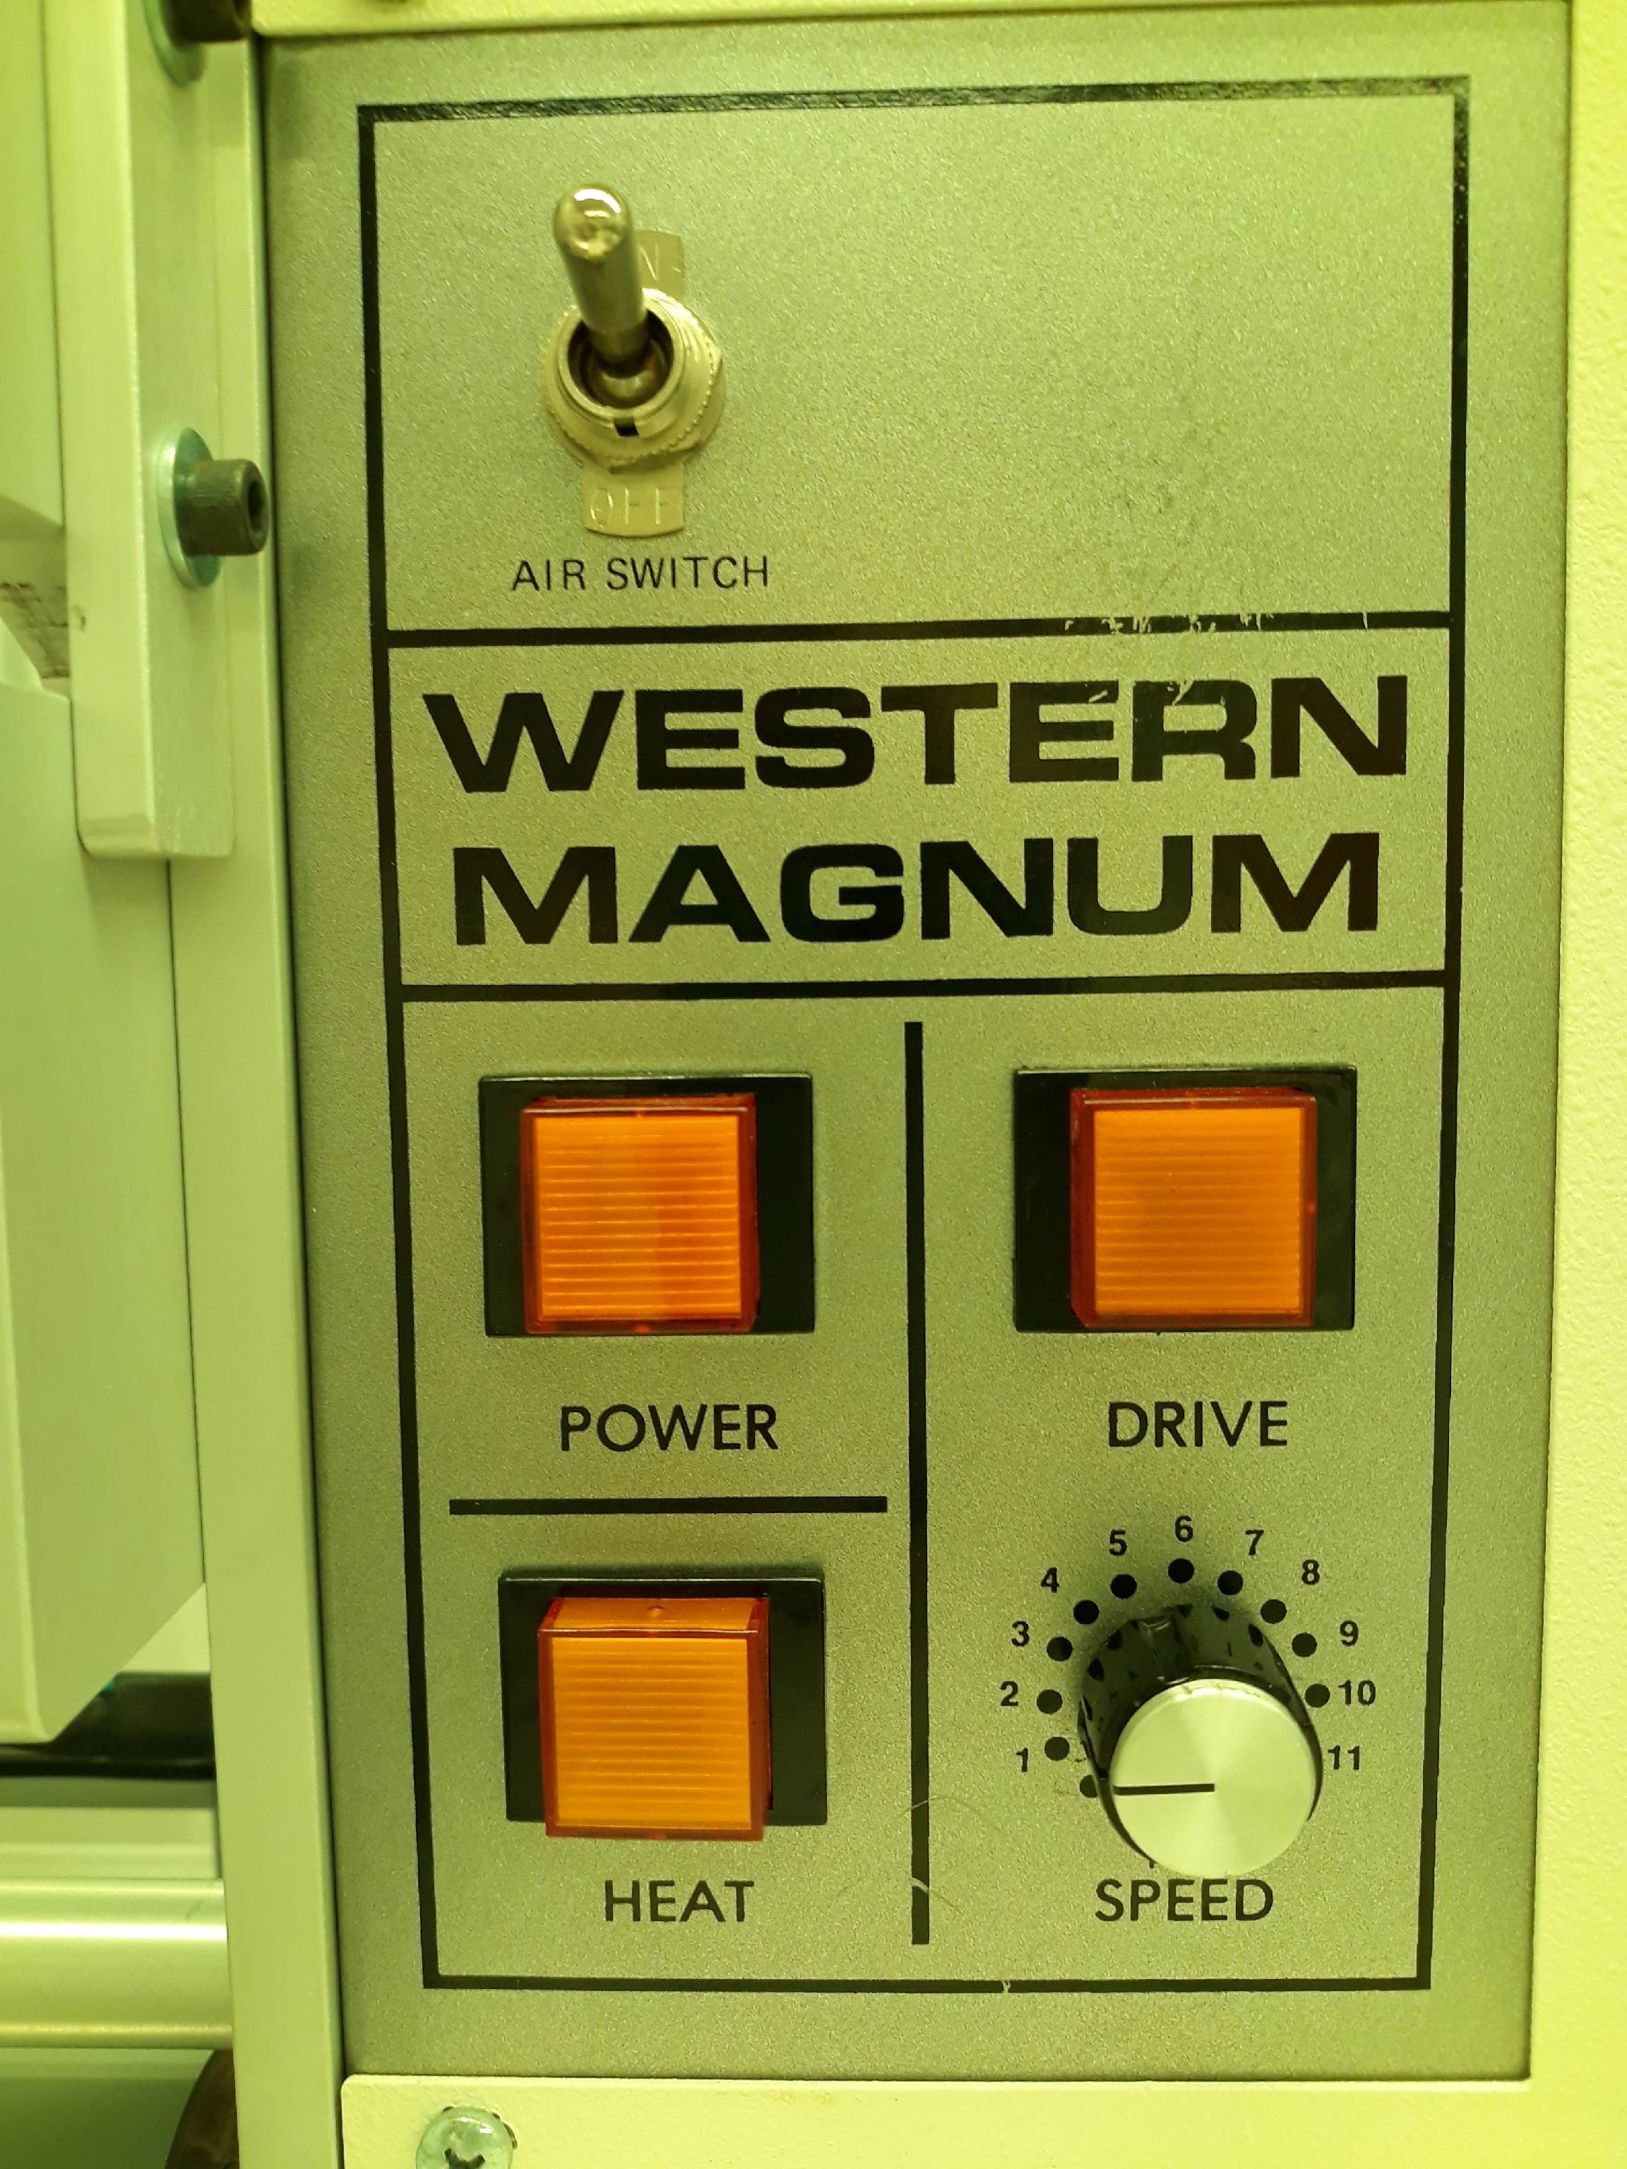

Roller Heater Controller
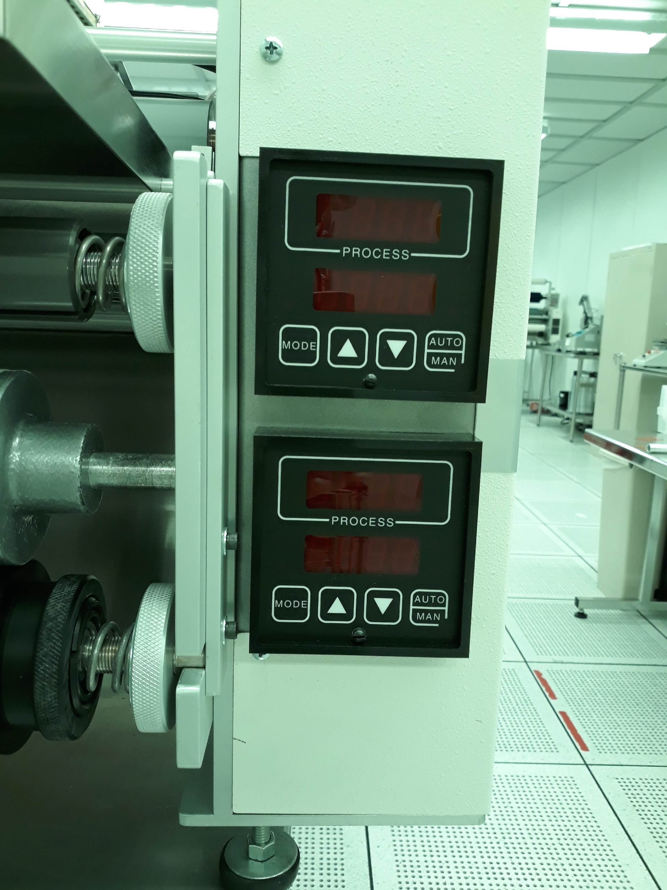

Roller Pressure Control


