FLEXIBLE DISPLAY CENTER | Document Owner:  Nick Munizza | Release Date:
Document Title:  Yamato Oven Operating Procedure | Document No: | Document Rev: 01

SPECIFICATION FORMAT:
EQUIPMENT MANUFACTURER: |  |  | Yamato
EQUIPMENT MODEL: |  |  | DP 63
FDC ASSIGNED TOOL ID NUMBER: |  |  | ASU Property Control#  4053649  4053696
APPLICATION PROGRAM(S) AND REVISION: |  |  | Microsoft Word 2003

SIGNATURES FOR RELEASE OR HISTORY ON FILE IN PRODUCT SPECIFICATIONS |  |  |  | Confidential Proprietary
ORIGINATOR:  Nick Munizza |  |  |  | The information contained in this document is the property of the Flexible Display Center at Arizona State University. No information contained in this document may be disclosed outside of the Flexible Display Center at Arizona State University at any time.
RESPONSIBLE ENGINEER:
Emmett Howard
DIRECTOR OF OPERATIONS:

Table of Contents
1.0 Purpose 3
2.0 Scope 3
3.0 Associated Materials and Equipment 3
4.0 Safety 3
5.0 Procedures 3

Purpose
  - To define the operating procedures for the Yamato Vacuum Drying Oven processes.

Scope
  - Describe documentation for Process and Data Records.

- Associated Materials and Equipment
  - SS rack(s).
  - Ionizing N₂ gun for particle blow-off of sample if applicable.
  - Vacuum wand for loading samples.
  - Clean room wipes
  - Material(s) for baking.

- Safety
  - Temperature range for DP63 is from 0ºC to 220ºC. Do not exceed 220ºC.
  - When using a very wet sample, try to drain it as much as possible before putting it in the chamber.

- Procedures

  - The oven should be at atmosphere. Check the sign on front of the oven door to see if it is “in use” or “available”.
  - If the sign reads “in use”, then, the oven is running a process and should not be tampered with until the run is complete.
  - If you are still unsure then contact the area Engineer.

- Recipe Programming
  - How to program a recipe
    - Press the MODE key
    - Press the up/down key until PROG appears.
    - Press ENTER.
    - Pr.1 will appear. If this is a new recipe, toggle to a program number not currently used.
    - Press ENTER.
    - SG 1 appears.
    - Press ENTER.
    - STEP appears.
    - Press ENTER.
    - Set the desired (soak/dwell) temperature by using the up/down key.
    - Press ENTER.
    - Enter the desired (soak/dwell) time.
    - Press ENTER.
    - SG 2 appears.
    - Press ENTER.
    - STEP appears.
    - Enter the ramp down temperature.
    - Press ENTER.
    - PR 2 appears.
    - Press the ESCAPE key twice to set.
  - Selection of operation menu
    - Press the MENU key and select the programmed operation.
    - The operation menu lamp of the PROGRAM blinks.
    - PROG will appear on the sub display and the execution program number can be input.

  - Input of execution program number
    - Press, either the up or down key to indicate a desired program number on the main display and press ENTER.

- Loading Yamato #3 Oven
  - Insert sample(s) into the chamber and place onto 1 of 4 oven racks.
  - Close the door until door latch is locked into place.

- Run Procedure
  - Once the oven has been loaded, start the cycle pump down and purge procedure
    - Close the Purge (switch down)
    - Open the Pump (switch up)
    - Once the vacuum has reached -0.08, close turn Pump off (switch down)
    - Open the Purge (switch up)
    - Once the vacuum has reached -0.02, close turn Purge off (switch down)
    - Repeat the above 3 times.
    - After the 3rd purge cycle, turn the Pump on and let run.
  - Program Recipe
    - On the controller, press the “Menu” button multiple times until the green light is flashing next to “Program”.
    - Pr.1 will also be flashing and will need to be changed.
    - Press the up arrow until Pr.2 is flashing.
    - Press enter.
    - .01 will flash.
    - Press enter.
    - The bake program is now set and will be running.
  - Bake Program Completed
    - Close the pump (switch down)
    - Open the purge (switch up)
    - Purge time can take up to 5 min before the chamber is at atmosphere.
    - Once oven has reach atmosphere you can open the door.
    - Remove material(s)
    - Close door.
- Photos
Yamato DP63
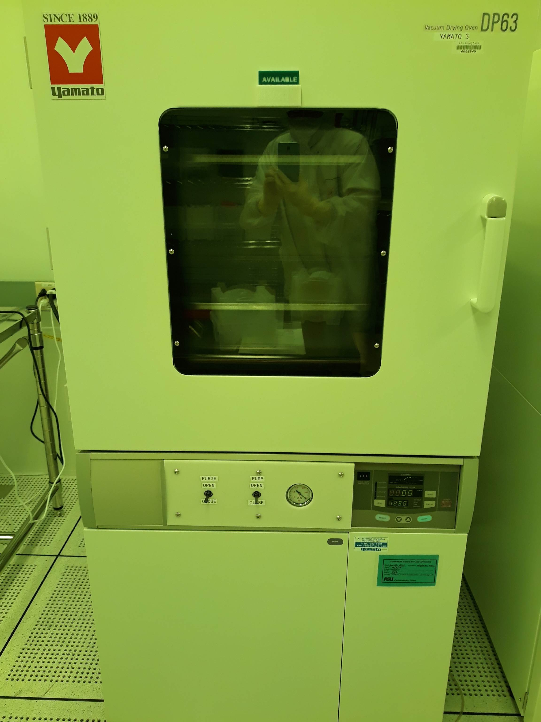

Front Panel
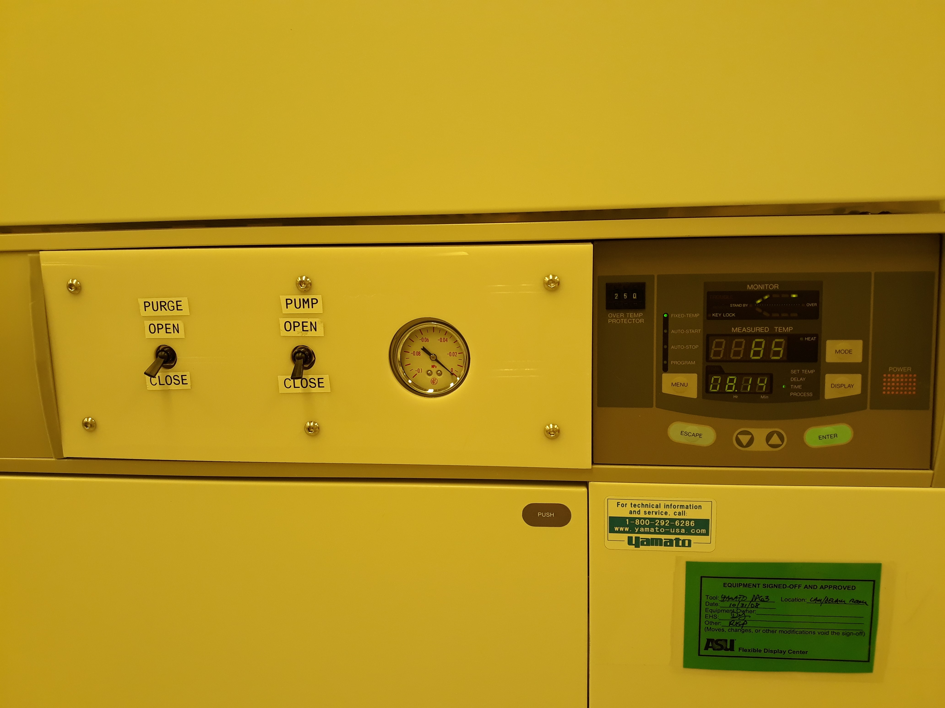

Controller
