Advanced Electronics and Photonics (AEP) Core Safety Handbook
2019-20

Rules and Procedures 2019-20
Contents
Rules and Procedures 2019-20 2
AEP Core Directory 2019-20 3
Section I. Collective Commitment to Safety 4
A. Basic Safety Orientation 4
B. Penalties 5
C. Safety Links 7
Section II. Cleanroom Protocols 7
A. General Cleanroom Guidelines & Rules 7
B. Cleanroom Clothing Guidelines 10
C. SDS Information 12
D. AEP Core Provided Chemicals 12
E. Procedure for Ordering Chemicals for Usage in the AEP Core 13
F. Preliminary Hazard Assessment via the Chemical Approval Form 14
G. AEP Core Activity Specific Guidelines 14
Section III. Incidents and Accidents 18
٭IN THE EVENT OF AN EMERGENCY PLEASE DIAL 9-911 FROM ANY PHONE٭ 18
Section IV. Classes of Chemicals and Special Hazards 19
A. Hazardous Materials Defined 19
B. Paths for Chemicals to Enter the Body 20
C. Personal Protective Equipment (PPE) 20
D. Cleanroom Chemicals - General Safety Information 21
Bases 23
Examples: Sodium Hydroxide, Ammonium Hydroxide, Developers and Photoresist strippers. 23
Oxidizers 24
Example: Hydrogen Peroxide 24
Solvents 25
Examples: Methyl Ethyl Ketone, Acetone, Some Developers, Some Resists 25
Compressed Gas 26
Examples: Nitrogen, Argon, Helium Major Hazards: 26
E. Piranha Handling and Disposal Procedures 27
Piranha Disposal 27
There are a lot of horror stories about HF. Take them seriously! 28
Hydrofluoric Acid (HF) Exposure Response 30
Know these immediate actions BEFORE the incident. 30
G. Liquid Nitrogen Hazards and Handling 31
H. Engineered Nanoparticles 32
Section V. Chemical Sign-Out Procedures 33
Section VI. Hazardous Waste Handling and Disposal 34
*PROPERLY COMPLETED HAZARDOUS WASTE TAG* 36
Section VII. Chemical Spill Procedures 38
Appendix A: Glossary of Acronyms & Terms 40
Appendix B: Common and Correct (IUPAC) Chemical Names 41
Appendix C: Cleanroom and Building Floor Plans with Escape Routes and Equipment 43
Appendix D: Sample PHA/Chemical Approval Form 47
Appendix E: Safety Photographs 48
Appendix G: NFPA Hazard Diamond 52

AEP Core Directory 2019-20

Staff | Phone | Office | Email
Kevin Reinhart, Director of MTW | (480) 965-5178 | MTW 3620 | Kevin.Reinhart@asu.edu
Mike Marrs, Associate Director, AEP Lead | (480) 727-6898 | MTW 3621 | mmarrs@asu.edu
Emmett Howard, Associate Director | (480) 727-9510 | MTW 3622 | emhowar2@asu.edu
Ed Bawolek, Process Engineer Principal | (480) 727-9033 | MTW 3625 | ebawolek@asu.edu
Xan Henderson, Process Engineer Prin | (480) 965-9724 | MTW 3609-01 | xhenders@asu.edu
Rob Blanchard, Maintenance Engineer | (480) 727-9013 | MTW 3609-04 | rcblanch@asu.edu
Yong-Kyun Lee, Research Engineer | (480) 727-6515 | MTW 3609-08 | ylee64@asu.edu
Jovan Trujillo, Electronics Engineer | (480) 727-8660 | MTW 3609-07 | jtrujil1@asu.edu
Paul Yee, Process Engineer Sr | (480) 727-8909 | MTW 3609-06 | pyee3@asu.edu
Nick Munizza, Process Engineer Sr | (480) 965-2227 | MTW 3609-02 | nmunizza@asu.edu
Brian McNamara, EHS Director of MTW | (480) 727-8956 | MTW 1666 | brian.mcnamara@asu.edu

Facilities | Phone(s)
1st Floor Cleanroom Room 1511 (Gowning and Entrance) | 480-965-2971
1st Floor Cleanroom Room 1514 (Metrology) | 480-965-0186
1st Floor Cleanroom Room 1514 (Bruker XRD Land Line) | 480-965-7148
1st Floor Cleanroom Room 1514 (Evaporators and Furnace) | 480-727-9040
1st Floor Cleanroom Room 1514B (Photolithography) | 480-727-9038
1st Floor Shared Lab Room 1504 (Angstrom PVD) | 480-727-7733
1st Floor Shared Lab Room 1504 (Solvent Hood Land Line) | 480-727-0973
2nd Floor Cleanroom Room 2302 (Gowning Room) | 480-727-8907
2nd Floor Cleanroom Room 2205 (Build Lab) | 480-965-2512
2nd Floor Cleanroom Room 2206 (Dry Etch and AKT 1600) | 480-727-8904
2nd Floor Cleanroom Room 2206 (Solvent Hood) | 480-727-8660
2nd Floor Cleanroom Room 2208 (PVD, PECVD, Acid and Bases) | 480-727-8903
2nd Floor Cleanroom Room 2210 (Test and AFM) | 480-727-8970
2nd Floor Cleanroom Room 2215 (FESEM) | 480-727-8908
2nd Floor Cleanroom Room 2305 (Azores) | 480-727-8905
2nd Floor Cleanroom Room 2305 (Orbotech) | 480-727-8906
2nd Floor Cleanroom Room 2305 (Ellipsometer) | 480-727-4064
2nd Floor Cleanroom Room 2305 (Tamarack) | 480-727-4065
2nd Floor Cleanroom Room 2318 (Sunic OLED) | 480-965-7384
2nd Floor E-Test Lab Room 2506 | 480-727-7022

Section I. Collective Commitment to Safety

We must all be committed to maintaining a safe working environment: “No research is so important that it justifies endangering human health” (to quote from a College [now renamed the Ira A. Fulton School of Engineering] safety memo dated June 16, 1986). To this end, we have implemented an advisory procedure similar to industry’s “Safety Management By Walking Around” (SMBWA). All Core constituents are encouraged to participate in the SMBWA program. In short, we must all be vigilant. If you see something that does not look right, could be a hazard, etc. please report such concerns immediately to Core staff. The Core has made a serious commitment to become a role model in safety for the University. The Macro Technology Works building has safety officers to support and assist us with general environmental, health, and safety matters. Please feel free to contact AEP Core staff if you have any safety-related questions.

The Bottom Line on Safety
  - Ignorance of the rules, lack of common sense, language difficulties, carelessness, and haste are not adequate excuses for unsafe behavior

  - In spite of rules and staff supervision, primary responsibility for safety rests with the individual user

  - Please do not engage in activities that you do not have the time complete safely.

Basic Safety Orientation

The Center requires that prior to starting work all users of the Cleanroom and sample preparation laboratories attend:

  - The ASU Environmental Health & Safety (EHS) presentation on Laboratory Chemical Safety. Attendance at the ASU EHS safety class is a University policy requirement.

  - Fire Safety training, also presented by ASU EHS. This annual training is an ASU requirement.

  - Hazardous Waste Management training presented by ASU EH&S. This annual training is an ASU requirement. After the initial face-to-face session, this course may be completed online through ASU training annually.

Each user may require different training, so the training determination tool will select safety training specific to your needs. https://ehstrainingtool.asu.edu/

  - At this time, the AEP Core does have a formal training class for the cleanrooms. However, you will be required to attend a site orientation training class which is produced by the MTW safety officer, Brian McNamara. Please contact Brian for a schedule of classes and to be registered. The class is currently free to attend and is mandatory to attend prior to receiving badge access to the MTW building.

Individuals are further required to sign an agreement that they understand the AEP Core’s safety guidelines and the consequences for non-compliance (i.e. penalties). These classes serve only as an introduction to safety. Students, faculty and staff are encouraged to continue their education at every opportunity.

Examples:

- Attend EHS Refresher Training
- Review SDS of the chemicals you use
- Check vendor websites for updates
- Join SESHA, the Semiconductor Environmental Safety & Health Association.

Penalties

The goal of the AEP Core is the maintenance of a safe, collegial and pleasant working environment for faculty, staff and students. It is the intent of this document to encourage an attitude commensurate with this goal. However, the Core must have an effective method of recourse to discourage unsafe actions and penalize repeat offenders. Industry does not tolerate safety and environmental infractions: you are simply fired.

The Core has a 2-Strikes Policy with offenders in regard to matters of safety, hazardous chemical handling, waste, and disposal. Acts of criminal behavior will result in expulsion and/or termination. Criminal behavior is deliberate and willful disregard for safety procedures that results in a hazard to personnel, equipment, or facilities. Criminal acts will result in legal as well as disciplinary action.

We describe our day-to-day (actual current practice) uniform application of rules and procedures, including escalation toward a strike recommendation for major safety infraction. A strike can also result from repeated disregard to prior instructional safety warnings. One of our goals is to better educate you in matters of safety so that you will have a pleasant experience in the facility. The AEP Core has a Violation Escalation Policy in place. The following lists illustrate the violation ranking level and required actions by the AEP Core staff.

Example Violations:

Level 0
- No eye protection
- Failure to comply with AEP Core electronic device usage protocol
- Improper gowning

Level 1
- 3 of the same Level 0 events
- Chemicals left in hoods
- Failure to correctly fill out hazardous waste tag
- Failure to place waste in correct compartment

Level 2
- 3 of the same Level 1 events
- 5 unrelated Level 1 events
- Improper PPE
- Failure to label waste with a hazardous waste tag

Level 3
- 3 of the same Level 2 events
- 5 unrelated Level 2 events
- Failure to use secondary containment when transporting chemical
- Failure to observe buddy protocol (i.e. working in the lab alone)

Level 4
- 3 unrelated Level 3 events
- Unsafe chemical handling
- Unqualified tool handling
- Failure to observe safety protocol resulting in injury to self or other

AEP Staff Actions:
  - For Level 0 violations, a verbal warning will be documented in the AEP Core Safety folder by name, nature of infraction, and when it took place by the staff member making the observation along with any mitigating or aggravating circumstances. For the most part, these warnings are simple reminders to follow rules and procedures. No remedial action is taken since the purpose is to reinforce instructional value.

  - Three Level 0 verbal warnings for the same violation or any Level 1 violation will result in a written warning to the individual.

  - Level 2 violations result in written warnings and constitute a more serious disregard of rules and procedures and will be forwarded to the individual, their faculty/supervisor and AEP Core staff. ACTION is EXPECTED from the individual to remedy the infraction. For example, not labeling hazardous waste is not allowed: The corrective action would be to correctly label the waste as soon as possible.

  - Level 3 violations require a meeting with the individual, their faculty/supervisor and AEP Core staff.

  - Three Level 3 violations or a Level 4 violation results in an immediate strike recommendation. If an AEP Core staff member believes there has been a serious violation of the rules and procedure on an individual’s part, the staff is authorized to ask the individual to leave the facility immediately and shall report the incident to the Macro Technology Works (MTW) Safety Officer. Please be respectful and courteous should you be asked to leave the facility: Please do not be contentious. We will discuss the matter calmly afterwards. The MTW Safety Officer shall notify the AEP Core Director, Associate Director, and the individual’s faculty advisor in writing for strike recommendation.

    - First Strike: Access to all Center equipment and labs shall be revoked until the individual and his/her advisor meets with the Center Director (or designee) to discuss the circumstance of the violation. ASU EHS may also be invited for assistance. The individual must write a personal improvement plan to be approved by AEP Core.

    - Second Strike: Access to all Center equipment and labs shall be permanently revoked following recommendation by the Executive Council (as serious threat to maintaining a safe working environment within the Center). Further penalties may be imposed to fit the severity of the violation. This may result in financial penalties, termination of academic program with AEP Core/ASU and/or employment termination procedures with ASU.

Safety Links

This safety document has been prepared by Center members (faculty, staff, and students) and representatives from the ASU Environmental Health & Safety (EHS) Department. The document outlines the current chemical handling procedures and policies regarding safety within the Center. This original document was enacted on 12/30/2019. Revisions and updates of this document will occur on a periodic basis.

If there is a conflict between AEP’s guidelines and those of the University, the University rules shall prevail.

Please also visit the ASU web sites below for more detailed information on hazardous waste management policies:

The University Environmental Health & Safety (EHS) homepage can be found at:

https://cfo.asu.edu/ehs

Please also visit the web-site below for Incident Report forms, links to Safety Data Sheets (SDSs), hazardous waste pick-up requests, responsible party information and other safety-related topics.

https://cfo.asu.edu/ehs-assistant

Please note that the MTW building safety office requires an SDS from the manufacturer of the chemical to be used. A generic SDS downloaded from another website can not be submitted instead.

Section II. Cleanroom Protocols

Note: Rules are shown in Bold Procedures and FYI’s are italicized

It is important that a uniform safety code exists throughout AEP Core. The Cleanroom protocols outlined below apply to all of AEP Core laboratories with chemical usage. These shared and dedicated laboratories include: MTW 1504, MTW 1514, MTW 2206, MTW 2208, MTW 2209, MTW 2210, MTW 2305, MTW 2328, and MTW 2506. Hazardous waste (by regulatory code) must be contained in the laboratory in which it is generated. Disposal of waste is handled by MTW EHS. Hazardous waste pickup requests can be made with the MTW Safety Group by contacting one of the following safety officers:
- Darren Miller, darren.miller.1@asu.edu, 480-254-6806
- Randy Lewis, randy.lewis@asu.edu, 480-298-0009

General Cleanroom Guidelines & Rules

  - Do not work in the Cleanroom if you feel particularly tired or unwell (e.g., heavy cold or allergies) or if you have taken even a small amount of medication or alcohol.

  - All personnel must wear safety glasses or goggles while they are in the Cleanroom. Contact lenses are not allowed in the Cleanroom.

  - Always use the ‘Buddy System’ when working in the Cleanroom after normal working hours, which are: Monday – Friday, 8AM – 5PM. Do not work alone outside of these hours. Please note that all labs are closed between Midnight (12:00 AM) and 6:00 AM. Do not be in the labs after Midnight (12:00 AM).

    - “Buddy-1” applies to the Cleanroom and Liquid Nitrogen fills: Compulsory buddy system applies for outside of normal working hours. Buddies must be valid users of the cleanroom.

    - “Buddy-2” applies to all Center laboratories with chemicals: At this time, Buddy-2 will only apply to MTW 1504 and MTW 2506 which lie outside of the MTW cleanrooms. The Buddy-2 ‘collegial’ advisory is as follows: Outside of normal working hours we strongly recommend that for your own safety you inform an associate or colleague: of your whereabouts; what you plan to do; how long it will take you; etc. The Buddy-2 support person can be located anywhere within MTW. The key point is that if the support person doesn’t see you or hear from you in a while, e.g. you are long overdue, the expectation is that in the spirit of mutual concern for each of our well-being, the support person would follow up to see if anything is amiss. We also suggest periodic lab check-ups during the course of any extended twilight research activity. We have clearly identified those Center laboratories deemed “Buddy-2” with signs on the doors to aid your recognition of the Buddy-2 system.

Personal cleanliness is essential for any cleanroom environment. Makeup, of any type, is forbidden in the cleanroom.

  - No dangling jewelry is to be worn in the cleanroom.

  - For SAFETY reasons, shorts or bare midriffs are not allowed in the cleanroom.

  - Shoes shall cover the entire foot with no open toes, sides, or heels and must be worn when handling or disposing of chemicals. No sandals, flip-flops, or high heels over 1.5”.

  - No food or drink of any kind is allowed in any MTW lab. Food or drink includes such items as: candy, gum, cough drops, coffee, water, etc. There is an eating area on the first floor in the old Motorola café near the center of the building. Food and drink is also permitted in the AEP Core office if you have been granted access.

  - Smoking is allowed only in designated areas outside the building per the Smoke-Free Arizona Act – Arizona Revised Statutes, Title 36 § 36-601.01.

  - Safety apparel must be worn when handling or disposing of hazardous chemicals. The minimum appropriate apparel for each class of chemical must be worn. This includes safety glasses or goggles, face shield, chemical gown, and chemical gloves and/or nitrile gloves.

  - All personal items such as backpacks, makeup, combs, brushes, handkerchiefs, hats, electronics, etc. are not to be brought into the clean room or the dressing area. Work-related items which are brought into the cleanroom must be wiped down thoroughly with cleanroom wipes.

  - Only clean room paper and lab wipes will be brought into and used in the clean room. Notebooks, specifications, memos, schematics, magazines, or any form of correspondence are not to enter the clean room area unless they are laminated, in plastic covers, or on authorized clean room paper.

  - For SAFETY reasons, do not sit on worktables or lean on wet benches or equipment.

  - No spray cans or powdered materials are allowed in the clean room.

  - No cardboard boxes or packaged materials are to be brought into the clean room.

  - Any debris on the floor or at a workstation is to be picked up and disposed of. Assume the responsibility for a clean, neat and safe work environment.

  - Due to the potential hazards of residual gases and other chemicals in tools, if a tool malfunctions while you are using it you must contact a Staff member immediately and flip the tool status sign (if present) to the “DOWN” position (or post a note on cleanroom paper).

  - Each user will be responsible for correct disposal of all hazardous waste as stated in Section VI. Storage of hazardous waste in the Cleanroom is NOT permitted. All hazardous waste chemical bottles MUST have a properly completed hazardous waste tag attached.

  - AEP Core electronic device usage:
    - Voice calls on cell phones only allowed in gowning room
    - No electronic device usage when operating tools or using PPE
    - No earbud usage with any electronic device
    - Tablet usage allowed with the same guidelines as cell phones
    - No laptops allowed in cleanroom except for vendors and staff during tool repair/maintenance

  - Individuals are strongly encouraged to advise/caution/educate other facility users who are not complying with safety guidelines and protocols. Please report the individual/incident to AEP Core staff if the person continues to act in an unsafe manner.

  - Chemicals (in glassware or original bottles) are not to be stored in wet benches. Squirt bottles of approved common solvents are permitted in solvent benches. Users who need to run long or unattended wet chemistry experiments are required to obtain prior approval in writing from an AEP Core Staff member. Please send an email to all AEP Core Staff (AEPcore@asu.edu) with your request. These experiments must be clearly marked and labeled, i.e. state the nature of chemicals, the user name, a contact phone number, and date and time experiment will be completed. AEP Core staff will dispose of unapproved experiments. All individual user (custom) chemical bottles must have the same appropriate labeling. All unmarked beakers, samples, bottles, etc. will be removed at the end of the normal workday by AEP Core staff.

  - Acids and other hazardous chemicals must be transported safely. To transport hazardous chemicals, the use of a bottle carrier or “acid bucket” is mandatory.

  - Users must clean & dry wet benches after their work is completed.

Cleanroom Clothing Guidelines

  - Everyone entering the clean room will be required to wear an appropriate clean room garment. The apparel will include: face mask, hair net, hood, cover-all (bunny suit or frock depending on the cleanroom), boots, safety glasses or goggles, and disposable gloves.

  - Cleanroom attire for second floor cleanroom will be put on in the following order: booties, face mask, hair net, gloves, hood, bunny suit, boots, safety glasses. The attire is to be removed in reverse order: Safety glasses, boots, bunny suit, hood, gloves, hair net and face mask. The clean room garment is to be completely zipped up to the neck and the snap used to secure the collar area. The glove cuffs are to be placed under the garment sleeve cuffs and secured around the wrist. No street clothing is to be visible outside the cleanroom garment.

  - Boots must cover the shoes and have the legs of the bunny suit tucked inside the booties.

  - All hair must be tucked inside the hair net and the flap of the hood must be completely inside the bunny suit.

  - Cleanroom attire for Room 1514 will be put on in the following order: booties, face mask, hair net, gloves, frock, safety glasses. The attire is to be removed in reverse order: Safety glasses, frock, gloves, hair net and face mask. The frock is to be completely zipped up to the neck and the snap used to secure the collar area. The glove cuffs are to be placed under the garment sleeve cuffs and secured around the wrist. Your pants will be visible from the bottom of the frock.

  - Clean room garments are to remain completely zipped up while in the clean room.

  - Clean room attire is not to be worn in a non-clean room area except in an emergency. The garments are to be stored in the dressing area on a hanger and hung on the rack. Please use the visitor garment racks.

  - Clean room garments are to be changed once a week. If the garment becomes damaged or badly soiled, then it should be changed immediately.

  - Shoes should be clean and free of dried mud, dirt, etc. before entering the dressing area.

  - Do not touch your face, nose, mouth, or bare skin area while wearing the gloves in the clean room. This would introduce contamination to the product and/or the equipment.

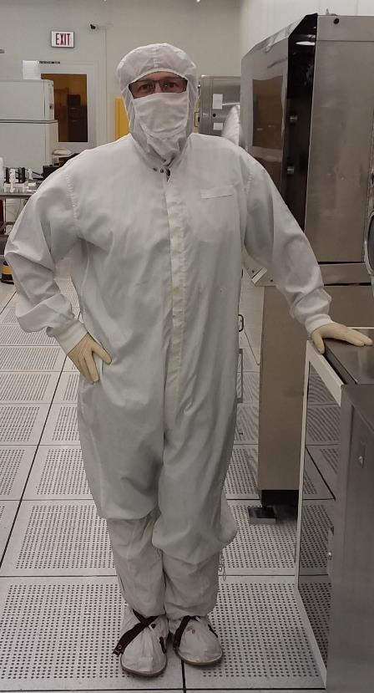

Standard Cleanroom Garment for the Second Floor Cleanroom

SDS Information

All users must read the SDS thoroughly and understand the properties and hazards associated with using or mixing chemicals.

  - SDS’s are available for all chemicals used within the AEP Core cleanroom and its labs. They are located in the following areas:

    - Master copy for 1st Floor Cleanroom: Located in Room MTW 1511
    - Master copy for 2nd Floor Cleanroom: Located in Room MTW 2302
    - Labs: Only the chemicals which are approved, stored and used regularly in these labs have an SDS located within.

AEP Core Provided Chemicals

  - AEP Core will provide the following general use chemicals. Please refer to Appendix B for proper (IUPAC) names of these materials.

Acetone Isopropanol  SRS-100 Resist Strip | Ammonium Hydroxide  Acetic Acid  Nitric Acid
Hexamethyldisilazane (HMDS) AZ 5214 Resist | Phosphoric Acid  10:1 Buffered Oxide Etch (BOE)
AZ 300 MIF Developer | Novacentrix B-40G Silver Nanoparticle Ink

  - AEP Core will provide the following chemicals for Evaporator use only:

MgF2
Nickel
AlF3
Chromium
90% indium oxide/10% tin oxide by weight
Titanium
TiO2 Black
Ta2O5
TiO2 White
MoO3
Aluminum
Molybdenum
Zinc

- Absolutely NO chemicals are to be taken into or transported out of the MTW facility (cleanroom, ancillary labs, or chemical storage/waste rooms) without prior and written approval of AEP Core staff. Please consult a AEP Core staff member if you have any questions.

- Gases

    - The following gases are currently installed in Room 1514 for use:
- Oxygen
- Nitrogen

    - The following gases are currently installed and plumbed to the second floor cleanroom:
- Oxygen
- Nitrogen
- CF₄
- SF₆
- Helium
- CHF₃
- Cl₂
- BCl₃
- CH₄
- HCl
- Argon
- SiH₄
- 1% B₂H₆/99% H₂
- 1% PH₃/99% H₂
- NF₃
- NH₃
- N₂O
- Hydrogen

Procedure for Ordering Chemicals for Usage in the AEP Core

The process for requesting new chemicals and chemicals that are not normally supplied and will be used in the AEP Core is as follows:

  - Determine if the chemical is currently supplied by the AEP Core. The chemical list is found in the Section II Subsection D above.

  - If the chemical is not supplied by the AEP Core, please submit a service request in iLab for the chemical. In the iLab chemical order request, please specify the desired quantity, chemical name, chemical formula, and supplier.

  - The MTW Safety Compliance Officer will then determine if a PHA is required. If required, AEP Core personnel will work with the researcher to have the PHA form filled out and the appropriate SDS obtained from the manufacturer/vendor.

  - If approved for purchase the AEP Core will obtain a quote for the chemical. The quoted dollar amount will be reflected in the iLab service request for you to approve. Any additional costs, such as shipping, will be transferred to the requestor. There will be no charges for AEP Core personnel time.

  - Once the requestor has approved the quoted amount, AEP Core Staff will order the chemical, provide details of the delivery, and notify the requestor when it has arrived. Once the chemical has been delivered to the AEP Core, the chemical will remain in the AEP Core.

This process eliminates paperwork, delivery issues, and allows the AEP Core to purchase, store, and use the chemicals per the AEP Core’s and ASU’s safety and purchasing policies. The AEP Core is responsible for chemicals used and stored in the AEP Core. Therefore, standard cleanroom chemical usage and storage protocols defined in this Safety Handbook will be used and enforced by the AEP Core staff.

For questions or problems with iLab chemical purchase requests please contact: AEPCore@ASU.edu

Preliminary Hazard Assessment via the Chemical Approval Form

The purpose of the Chemical Approval Form:

  - It provides lab-specific accountability for the chemicals used in the AEP Core.

  - The exercise of writing this document is to ensure that the chemical user understands the hazards and has thought through the process he/she is planning. This is also a right-to-know step to ensure that all users of a chemical have reviewed the chemical SDS and understand its properties and hazards.

- An original Chemical Approval is required:

  - For chemicals that are new to the AEP Core (refer to Section IID. 1, 2, and 3).
  - For chemical mixes and processes that are new to the AEP Core. (If in doubt, contact AEP Core Staff)
- An amended Chemical Approval is necessary:

  - For chemicals and materials that someone else brought into the AEP Core, and you now wish to use (at AEP Core discretion. You may be required to submit a new PHA)
  - To take ownership of chemicals from someone who is graduating or leaving
  - To join a project already in progress by your group as a co-experimenter
  - To change process details of a chemical approval you have already completed

Please attach another chemical approval form to a copy of the original chemical approval form sheet describing the changes (people added, chemicals added, process changes, etc.), supply any needed MSDS, and make sure that all experimenters sign it before submittal of the form. There is no need to copy all of the original information onto a new sheet, but must be able to explain the process, chemicals, and hazards.

Users who require other chemicals are required to complete a chemical approval form for the use and disposal of the chemicals. At the discretion of the MTW safety officer, a more thorough material handling plan may be required. The chemical approval form can be found in Appendix D. Prior to ordering, the user is to complete the chemical approval form which will include a step-by-step plan for the chemicals, including use quantity, frequency and location of use, tools used and chemical disposal, per the following steps:

- The user is to obtain the Safety Data Sheets (SDS) sheets for the planned/proposed chemicals prior to ordering.

- The user is to complete the chemical approval form and submit it to MTW Safety Personnel. If there are no issues or concerns, the user will be notified of approval by MTW Safety Personnel. In the event that approval is not given, the user is advised to consult MTW safety personnel to determine proper resolution to any deficiencies.

- Upon receiving approval to use the chemicals, the user shall provide 3 copies of the MSDS to AEP Core Safety Personnel. It shall be the user responsibility to place the MSDS in the lab MSDS binder.

AEP Core Activity Specific Guidelines

What follows are AEP Core specific rules regarding the usage of specific equipment.

Users of Any AEP Core Equipment

Users of any AEP Core equipment will need to follow these basic rules in addition to the safety rules outlined in the previous sections:

- Do not stray from the equipment you have been trained on. The second floor cleanroom is especially large and is full of equipment dangerous to the untrained. Usage rights will be revoked for any user caught using equipment they have not been properly trained on. In addition, damage to equipment will be billed to the user.
- Note the location of exits and fire extinguishers. Consult the appendix for floorplans of the main AEP Core lab spaces. Do not be afraid to ask AEP Core personnel to show you the location of the exits, eye rinse stations, fire extinguishers, etc. We are here to help.
- Until iLab is setup, you must report all equipment use (unattended or not) to Michael Marrs (mmarrs@asu.edu) on the day of usage.
- All equipment usage will require billing information provided PRIOR to training. The grant account number and principal investigator is sufficient for ASU internal users. External users will need to issue a PO prior to use until iLab is setup.
- Access to the AEP Core is at the will of the AEP Core and MTW EH&S. Access may not be granted to sensitive locations such as the Sub Fab or the Fan Deck as there is a lot of construction in progress. Access requests will be reviewed on a case by case basis by EH&S.

Metrology Equipment (Tier 1)

Metrology equipment is defined as equipment that provides some sort of measurement. Tier 1 metrology equipment provides the least danger to the user and AEP Core equipment. The following AEP Core equipment would be considered Tier 1 metrology equipment:

Explorer Pro Scale
Sartorius Scale
Goniometer
Flex Tester
OAI-311 Intensity Profiler
Tencor 6200 Particle measurement
Microscope with Nomarski and imaging software 150mm
Woollam Ellipsometer M2000
VeecoWyco SP3000W Interferometer
Tamar WaferScan
Imada DS2-11 Force Gauge and Imada Pull Tester
Imada DS2-11 Force Gauge and Jinlong Pull Tester
Olympus MHL110 Microscope
Microscope panel inspection stations w/ camera GEN II
P16+ Profilometer 150mm
Thermo Nicolet 6700 FTIR
Tencor FLX-2350FP
Bagging station
Optical Microscope for Critical Dimensions
KLA Omnimapper 4 point probe
Ecopia, HMS-5000, Hall Measurement System
PL wafer mapping (Nanometrics)
Candela
KLA Stylus P2 Profiler
Filmetrics Reflectometer
MicroManipulator #1
MicroManipulator #2
UV-Vis Spectrometer

Tier 1 metrology equipment should only take one or two training sessions of one hour to become proficient at using the equipment and therefore ready to begin unattended use. Please remember that all decisions with respect to unattended usage rest with AEP Core personnel. We will not unreasonably deny access, but we do expect reasonable proficiency to be demonstrated.

Tier 1 equipment is safe enough to operate that in the event of a hardware failure or loss of power, rebooting the controlling computer and rehoming the equipment will be permitted. AEP Core personnel should be flagged for more serious or complicated issues.

Metrology Equipment (Tier 2)

Tier 2 metrology equipment is significantly more complicated or more dangerous to operate. Tier 2 equipment may require additional training sessions before unattended usage is granted. Efforts will be made to restrict unattended usage to a single “expert” user from each organization.

The following AEP Core equipment will be considered Tier 2 metrology equipment:

FP-10 Stylus Profilometer
Orbotech FPI-7098M
JEOL 6300 FESEM
Tencor AFM
Bruker XRD D8 Discover
CURTIS Laser Repair

Failures to Tier 2 equipment should be left AS IS WHERE IS if at all possible. Do not attempt to restart or reboot or home the equipment yourself. You will be billed for damage caused to the equipment.

Metrology Equipment (Tier 3)

Tier 3 metrology equipment is restricted to usage by AEP Core personnel only. Equipment in Tier 3 may be exceedingly dangerous or have special scheduling concerns that currently do not allow unattended operation

The following AEP Core equipment is considered Tier 3 metrology equipment:

GEN II Bow Warp
Park 150 AFM 150mm
Frankenprober (Electroglas 150 mm prober #1)
Pestilence (Electroglas 150 mm prober #2)
Famine (Electroglas 150 mm prober #3)
War (Electroglas 150 mm prober #4)
Trinity (Electroglas 150 mm prober #5)
Fluffy White Bunny (370 mm x 470 mm prober)
CHERRY Laser Repair
Sloth Laser Repair
PR 670 camera station

Operation of the Tier 3 equipment will be limited to AEP Core personnel.

Processing Equipment (Tier 1)

Processing equipment at the AEP Core is any equipment used in the fabrication of an electronic device or material. The AEP Core has a wide selection of photolithography, physical vapor deposition, chemical vapor deposition, wet and dry etching equipment available. The processing equipment is separated into 3 tiers. Tier 1 equipment is the safest equipment to use and will require the least training prior to unattended usage. In some cases, Tier 1 equipment may require additional safety training which will be disclosed when inquiring about the specific equipment. Tier 1 processing equipment at the AEP Core includes:

Spin Rinse Dryer
CHA Metal Evaporator
CHA TCO Evaporator SR-10
Angstrom Evaporator
Mini Brute Tube Furnace - Model MB-80
AlWin21 RTP
Laurell WS400B Spin Coater
VWR Hotplates
Cole-Parmer Hotplates
Dymax 2000 UV i-Line Exposure
Dymax 5000 UV i-Line Exposure
Western Magnum XRL180 Laminator
Yamato DP43 Vacuum Bake Oven
Yamato DP63 Vacuum Bake Oven
SunTec Laminator
DEK ELA Screen Printer
LanTec UV Ozone Cleaner and Exposure
Solvent Hood
SPS PolyPro Wet Hood
Solvent Hood
Tegal 903
Tegal 901
GaSonics L3510
Tegal 965
Yes HMDS Vapor Prime Oven - Model YPS-3
Cee Coater - Benchtop system Model 300
EVG 610 Aligner - Setup for 4" and 5" masks
Acid Wet Bench - Amerimade
Diener Plasma Etcher
Dimatix Inkjet
Prism Ultra-Coat 300

Tier 1 equipment can be safely restarted and homed in the event of a machine failure or power outage. Error recovery should be covered as part of the initial training.

Processing Equipment (Tier 2)

Tier 2 processing equipment may require additional training sessions above and beyond what is required for Tier 1 processing equipment and may include additional ASU safety training classes. In addition, access to Tier 2 equipment may be restricted to one or two “expert” employees from each academic group at the AEP Core’s discretion. Failures to Tier 2 equipment should be left AS IS WHERE IS if at all possible. Do not attempt to restart or reboot or home the equipment yourself. Extreme damage can occur if untrained individuals attempt to improperly recover from a machine error. You will be billed for damage caused to the equipment. Tier 2 processing equipment at the AEP Core includes:

MRC-603A
MRC-603B
AMAT P5000
AMAT 8330
EVG501 Bonder
EIT Asher
Pokey (370 mm x 470 mm solvent resist strip)
HMS Hood (370 mm x 470 mm BOE hood)
Robin Hood (370 mm x 470 mm SC-1 hood)

Processing Equipment (Tier 3)

Tier 3 processing equipment is restricted to AEP Core personnel operation only. Tier 3 equipment can be exceedingly dangerous or complicated or may have scheduling issues do to ongoing AEP Core projects with outside vendors which require the equipment to be tightly controlled. Tier 3 processing equipment at the AEP Core includes:

KDF 744
Rite Track (SVG) 8600 Coater and Developer Track
Rite Track (SVG) 8800 Coater and Developer Track
Canon MPA-600FA
YES-15 HMDS Oven
Sunic
EVG 150 Coat
EVG 150 Developer - DI Rinse Cleaner
Azores
nTact Slot Die Coater
AKT 1600
Suss MicroTec (Tamarack) UV I Line Exposure
Despatch Oven

Section III. Incidents and Accidents

- Incidents and Accidents: An “incident” is any event, large or small, that either causes or has the potential to cause personal injury or damage or loss of property or equipment. All incidents MUST be reported per ASU EHS-115 policy. An Incident Report form may be found and completed at https://cfo.asu.edu/incident-reporting. Follow the instructions per EH&S.

If you or your experiments are involved in an incident as defined above, you must notify AEP Core staff and complete an EH&S incident report. Failure to complete an incident report will result in the loss of lab and/or cleanroom privileges per the violation policy.

- If you are injured at work: No matter how minor the job related injury/illness or accident may seem, it must always be reported within 48 hours of the occurrence by calling (602) 542-WORK or 1-800-837-8583. Notify your supervisor: they must fill out an “Employer’s Report of Injury” form (must be completed and returned to the Customer Service Center no later than 9 days after the occurrence.

- Failure to report within those time frames can result in severe monetary fines, payable by your department. Prompt reporting will accelerate the processing of the claim and will avoid unnecessary delays or denial of possible benefits, and/or penalties.

- You may report directly to ASU Student Health http://www.asu.edu/studentaffairs/health/ or Tempe St. Luke’s emergency (1500 S. Mill Ave, Tempe) for initial treatment unless the injury/illness is serious or Student Health is not open. If the injury/illness is serious or Student Health is closed, you should call your primary care physician or report to the nearest emergency room. Incident reports and the Employer’s Report of Injury must still be filed.

٭IN THE EVENT OF AN EMERGENCY PLEASE DIAL 9-911 FROM ANY PHONE٭

The telephones in the two cleanrooms are all voice over IP telephones that SHOULD be properly registered with ASU Emergency Services. However, just in case, one should provide the following information when dialing 911
Please provide the following Response Information:

Address: ASU/Macro Technology Works Building
7700 S. River Pkwy Tempe, AZ 85284
Building: #535 Macro Technology Works
Room and Phone Number: 1504 (1st floor Angstrom Lab), 480-727-0973
1514 (1st floor cleanroom), 480-965-0186
2305 (2nd floor photo area), 480-727-8906
2208 (2nd floor dep area), 480-727-8903
2206 (2nd floor etch area), 480-727-8904

Section IV. Classes of Chemicals and Special Hazards

Chemicals and Safety: General Cleanroom (Fab) Guidelines

We live in a chemical environment. Chemicals are all around us – in our homes, at work, in the air, and in our food. When working with chemicals and gases, the first reaction one has is, "DANGER", but if handled properly and with a little thought, they can be quite safe. Remember, all substances are poisons; only the dose separates a poison from a remedy.

In the Cleanroom or Fab (Fabrication) area, various types of safety equipment have been installed to provide you with the most practical protection possible. For your own sake, always use the appropriate Personal Protective Equipment (PPE); it is provided with your well-being in mind. If your PPE saves your eyes, or prevents a serious injury to you just once, it has been worth it. Good safety habits aren't just for you, but also for all other users. Be concerned for their safety as well as your own. If you see someone performing an UNSAFE act or not following safety regulations, make him/her aware of it. If someone does not take enough concern for him/herself, tell an AEP Core staff member. It is for your good as well as that of all other users.

Hazardous Materials Defined

Before we begin our discussion, we need to have an understanding of some basic terms and definitions.

  - Hazard: Source of Danger

Toxicity: Capacity of a substance to harm (poisonous).
    - Local Toxicity: Affects the part of the body it enters
    - Systemic Toxicity: Affects body organs regardless of the point of contact

  - Acute Exposure: Sudden, short.

  - Chronic Exposure: Long term

    - The relationship between toxicity, exposure, and individual susceptibility can be expressed as Dose/Response.

  - Threshold Limit Value or TLV: The amount of a substance to which the one can safely be exposed to over a specified period of time (usually eight hours a day, forty hours per week ).

  - Safety Data Sheet (SDS) for each material/chemical will tell you everything about the material being used, including flammability, reactivity, toxicity, safety and treatment.

The ASU Environmental Health & Safety (EHS) Lab Chemical Safety course must be completed as a requirement of the cleanroom orientation.

Paths for Chemicals to Enter the Body

In order for us to have a good understanding of safe chemical handling, we need to understand the way chemicals enter the body and some safe guards to use to protect ourselves:

  - Inhalation entry through nose and mouth are the most common way chemicals enter the body.
- Prevention: Exhaust hood, respirator.

  - Absorption through the skin, cut, or wound.
- Prevention: aprons, chemical gowns, rubber gloves, eye protection, approved footwear.

  - Ingestion- swallowing, also can be picked up from hands when eating, smoking, etc.
- Prevention- wash hands before eating or smoking.
  - Eyes- splashes, rubbing eyes with hands, etc.
- Prevention: safety glasses, face shield, ventilation, exhaust.

  - Injection
- Prevention: handle bottles carefully; be careful with sharp objects.

Personal Protective Equipment (PPE)

The AEP Core provides all users who work in the Fab area protective clothing and equipment. It's important that you know how to use this equipment and how to care for it. Listed below is some of the equipment and rules to follow when using it:

Chemical resistant gloves
- Face Shields
- Safety Glasses and Goggles
- Chemical resistant gown
- Chemical Transport Cart or Bucket

  - Any person working with acids, strong bases and/or solvents must wear safety gear.

  - Ensure proper fit; never alter or change protective clothing in any way and always wear it in the prescribed manner.

  - Inspect the gear before each use and test as necessary to ensure proper protection; remove from service if faulty.

- Chemical Gloves:
- Check chemical gloves periodically.

- Gloves must be washed off with water and dried frequently, especially before removing them. The Amerimade acid hood has a water sprayer and air gun which can be utilized if necessary.

- Never touch gloves with bare hands, always remove them at the same time and handle .

Cleanroom Chemicals - General Safety Information
Class | Acid | Base | Oxidizers | Solvents
Major Hazard | Corrosive: pH <4 | Corrosive: pH >9 | Liberates Oxygen | Flammable, some are  also toxic
Contact with  skin/eyes will result in: | Chemical Burns |  |  | Irritation & possible absorption of toxic  chemicals into body
Required PPE: | Safety Glasses or Goggles and Face Shield |  |  | Safety Glasses or Goggles  (No contacts)
Eyes/Face | Safety Glasses or Goggles and Face Shield
Body | Chemical Gown |  |  | N/A
Hands | Chemical-Resistant Gloves |  |  | Solvent-Resistant Gloves
First Aid Steps | Rinse for 15 minutes with water using eyewash, shower, or if appropriate faucet (spill on hand or wrist); another user in room should contact AEP Core staff member. Serious or life threatening  situations require calling 911 immediately.
For HF contact, apply
Calcium Gluconate to affected area. Refer to treatment of HF exposure for additional steps.
If any sensation (burning, itching) is noticed in affected area or if any chemical is splashed into
eyes, go to Tempe St. Luke’s hospital.
 | Complete Incident Report: https://cfo.asu.edu/incident-reporting
Handling | Read label and MSDS. Carry in chemical buckets
Segregation | Keep separate from: Solvents & Bases | Keep separate from: Acids & Oxidizers | Keep separate from: Bases | Keep separate from: Acids
 | Maintain HF separately
Use | Read MSDS. Always open & use chemicals under fume hoods to minimize chemical inhalation
 | Always add acid to water |  |  | Mixing solvents may result in undesired reactions. Keep separate unless known to  be compatible.
 | Mixing acids may result in undesired reactions. Keep separate unless known to be compatible. |  |  | If unknown odor is noticed, contact AEP Core staff.
Storage | Acid/HF Cabinet | Corrosive/Base Cabinet | Corrosive/Acid Cabinet | Flammable/Solvent  Cabinet
Spill Response | See Spill Response Chart, Section VII
Disposal | No drain disposal of chemicals or waste.
 | Refer to Waste Disposal Procedures, Section VI

Acids
Examples: Hydrofluoric, Nitric, Hydrochloric
Major Hazard: Corrosive. Will cause chemical burns to skin and eyes.
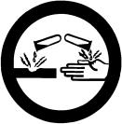
Characteristics:
  - Corrosive with a pH less than 4.
  - Usually non-flammable.
  - Soluble in water.
  - Will produce heat (burn) on contact with the moisture in your skin or eyes.

PPE: The corrosive nature of acids can result in serious, permanent damage to skin and eyes if contact is not prevented or controlled by PPE:
- Eyes: Face shield AND Safety glasses or goggles
- Hands: Acid Resistant Gloves
- Body: Chemical Gown

Handling/Use/Storage:
- Acid hoods are located in Rooms 1514B and 2208. See an AEP Core staff member if you have any questions.
- Read and understand the MSDS for the selected acid.
- Check labels to ensure correct acid was selected. Do not use chemicals that are not properly labeled.
- Acids and solvents do not mix. Keep them separate. Do not use acids in a solvent hood.
- Keep Hydrofluoric, Sulfuric, and Nitric Acid separate from other acids and from each other. Use secondary containment whenever possible.
- The corrosive characteristics of acids extend to their vapors. Open acids only in an acid hood and do not place your head in the hood.
- When handling acids, remember “A. A. A. Always Add Acid to Water”. Never add water to acid.
- Acids are to be stored only in the marked acid cabinet. Bottles returned to storage must be tightly capped, rinsed off and wiped down.

Spills: The best spill plan is to prevent spills from occurring. Use containment buckets when possible and pour and mix carefully. Extra precaution is required in crowded conditions and when visibility and dexterity may be impaired by PPE.
- Should a small acid spill occur (< 100 ml), use a clean room wipe wetted with DI to wipe the spill.
- Hydrion pH indicator tape has been provided at the acid and base hoods to assist in the identification of small acidic and basic chemical spills.
- Spills over 100 ml and up to 1 liter may require staff or EHS assistance.
- Evacuate the clean room and Contact AEP Core staff or EHS (480-727-8956) for spills over 1 liter.

First Aid: Because acids are water soluble, immediately rinsing areas of skin or the eyes that have been contacted with an acid will reduce the severity of the damage.
- Rinse area for 15 minutes.
- Seek medical attention at Student Health or Tempe St. Luke’s Hospital or Banner Desert Medical Center.
- Complete incident report or detail incident to supervisor so they may complete incident report.

Waste: Pouring chemicals down the improper drain is a violation of federal law.
- The person who uses the last remaining amount of chemical in a bottle must rinse the empty bottle three times, and then label the bottle “Rinsed 3X” with a permanent marker before discarding it.

- Acid waste which is not contaminated with other toxic materials such as arsenic or lead can be disposed of in the acid hood where the chemical was used. The MTW building has an onsite abatement facility which neutralizes any acidic or basic waste prior to release to the environment.

Bases

Examples: Sodium Hydroxide, Ammonium Hydroxide, Developers and Photoresist strippers.
Major Hazard: Corrosive. Will cause chemical burns to skin and eyes.
Characteristics:
- Corrosive with a pH greater than 9.
- Usually non-combustible.
- Will produce heat (burn) on contact with the moisture in your skin or eyes.

PPE: The corrosive nature of bases can result in serious, permanent damage to skin and eyes if contact is not prevented or controlled by PPE:
- Eyes: Face shield AND Safety glasses or goggles
- Hands: Chemical Resistant Gloves
- Body: Chemical Gown

Handling/Use/Storage Procedures
- Read and understand the MSDS of the base being used.
- Check labels to ensure correct base was selected. Do not use chemicals that are not properly labeled.
- Bases can react violently with acids and oxidizers. Keep them separate.
- Base hoods are located in Room 2208.
- Bases are to be stored in the Corrosive/Base cabinet. Bottles returned to storage must be tightly capped, rinsed off and wiped down.

Spills: The best spill plan is to prevent spills from occurring. Use containment buckets when possible and pour and mix carefully. Extra precaution is required in crowded conditions and when visibility and dexterity may be impaired by PPE.
- Should a small base spill occur (< 100 ml), use a clean room wipe wetted with DI to wipe the spill.
- Hydrion pH indicator tape has been provided at the acid and base hoods to assist in the identification of small acidic and basic chemical spills.
- Spills over 100 ml and up to 1 liter may require staff or EHS assistance.
- Evacuate the clean room and Contact AEP Core staff or EHS (480-727-8956) for spills over 1 liter.

First Aid: Immediately rinsing areas of skin or the eyes that have been contacted by a base will reduce the severity of the damage.
- Rinse area with water for 15 minutes.
- Seek medical attention at Student Health or Tempe St. Luke’s Hospital or Banner Desert Medical Center.
- Complete incident report or detail incident to supervisor so they may complete incident report.

Waste: Pouring chemicals down the improper drain is a violation of federal law.
- The person who uses the last remaining amount of chemical in a bottle must rinse the empty bottle three times, and then label the bottle “Rinsed 3X” with a permanent marker before discarding it.
- Base waste which is not contaminated with other toxic materials such as arsenic and lead can be disposed of in the base hood where the chemical was used. The MTW building has an onsite abatement facility which neutralizes any acidic or basic waste prior to release to the environment

Oxidizers

Example: Hydrogen Peroxide
Major Hazard: By providing additional oxygen, will allow a fire to burn “hotter” and more readily

Characteristics:
This class of chemicals liberates oxygen or causes oxygen to be released from other materials.

PPE:
- Eyes: Face shield AND Safety glasses or goggles
- Hands: Chemical Resistant Gloves
- Body: Chemical Gown

Handling/Use/Storage Procedures:
- Read and understand the MSDS of the oxidizer being used.
- Check labels to ensure correct oxidizer was selected. Do not use chemicals that are not properly labeled.
- Oxidizers are to be transported using a chemical bucket.
- Bases can react violently with oxidizers. Keep them separate.
- Must be stored separately from all other chemicals, especially reducing agents such as zinc or alkali metals.
- Keep away from any combustible materials (materials that can burn, such as papers or wood)

Spills: The best spill plan is to prevent spills from occurring. Use containment buckets and pour and mix carefully. Extra precaution is required in crowded conditions and when visibility and dexterity may be impaired by PPE.
- Should a small oxidizer spill occur (< 100 ml), use a clean room wipe wetted with DI to wipe the spill.
- Spills over 100 ml and up to 1 liter may require staff or EHS assistance.
- Evacuate the clean room and Contact AEP Core staff or EHS (480-727-8956) for spills over 1 liter.

First Aid:
- If an oxidizer comes in contact with your skin or eyes, flush with water for 15 minutes.
- Seek medical attention at Student Health or Tempe St. Luke’s Hospital or Banner Desert Medical Center.
- Complete incident report or detail incident to supervisor so they may complete incident report.

Waste: Pouring chemicals down the improper drain is a violation of federal law.
- The person who uses the last remaining amount of chemical in a bottle must rinse the empty bottle three times, and then label the bottle “Rinsed 3X” with a permanent marker before discarding it.
- Oxidizer waste which is not contaminated with other toxic materials such as arsenic or lead can be disposed of in the acid hood where the chemical was used. The MTW building has an onsite abatement facility which neutralizes any acidic or basic waste prior to release to the environment.

Solvents

Examples: Methyl Ethyl Ketone, Acetone, Some Developers, Some Resists
Major Hazards: Flammability and Toxicity

Characteristics:
- Most solvents have flash points (temperature at which sufficient vapors can collect to ignite) of less than 140°F (Class 2 liquids), many less than 100°F (Class 1 liquids).
- Some solvents are water soluble (methyl alcohol), some are not (petroleum based).

PPE: Human skin serves as a barrier to some toxins, but not to all. Some toxic solvents are absorbed through the skin into the body where damage to other organs can occur. PPE provides a barrier to these toxic solvents.
- Eyes: Face shield AND Safety glasses or goggles
- Hands: Solvent Resistant Gloves

Handling/Use/Storage Procedures
- Use in solvent hood. Inhalation (breathing in) of solvent vapors allows the toxin to enter the body.
- Read and understand the MSDS of the solvent being used.
- Do not use chemicals that are not properly labeled.
- Solvents are to be transported using a chemical bucket.
- Solvents can react violently with acids. Keep them separate. Do not use acids in solvent hoods or solvents in acid hoods.
- Solvents can react violently with one another. Do not mix solvents unless you know they are compatible.
- Store solvents in flammable/solvent cabinets.

Spills: The best spill plan is to prevent spills from occurring. Use containment buckets and pour and mix carefully. Extra precaution is required in crowded conditions and when visibility and dexterity may be impaired by PPE.
- Should a small solvent spill occur (< 100 ml), use a dry room wipe to wipe the spill.
- Spills over 100 ml and up to 1 liter may require staff or EHS assistance.
- Evacuate the clean room and Contact AEP Core staff or EHS (480-727-8956) for larger spills.
- Contact AEP Core staff or EHS for any unexplained smells or odors in the clean room or adjacent spaces.

First Aid: Immediately rinsing areas of skin or the eyes that have been contacted by a solvent will reduce the amount of solvent entering the body.
- Rinse area for 15 minutes.
- Seek medical attention at Student Health or Tempe St. Luke’s Hospital or Banner Desert Medical Center.
- Complete incident report or detail incident to supervisor so they may complete incident report.

Waste: Pouring chemicals down the improper drain is a violation of federal law.
- Bottles/containers: The person who uses the last remaining amount of solvent in a bottle must notify AEP Core staff, mark the bottle as empty and place it back in the chemical storage cabinet.

- Solvents: Waste solvents are to be collected in “pickle jars” underneath the solvent hood baths in Room 1514B or drained to solvent waste in Room 2206. These wastes are disposed of as AEP Core common bulk waste, so individual waste tags do not need to be made up. The solvent hood in Room 1514B is fitted with an interlock that will prevent draining if the pickle jar is full. If this occurs, please contact AEP core staff.

Compressed Gas

Examples: Nitrogen, Argon, Helium Major Hazards:
Chemical: Asphyxiation, due to the gas displacing
available oxygen AND the characteristic posed by the specific gas (some are toxic, some are corrosive, some are flammable, etc.)
Physical: Inadvertent, accidental release of pressure (from rupture or valve damage) can be devastating.
Temperature: Released gas will be much colder than in the compressed state. Care should be taken to avoid bodily harm from freezing temperatures.

Characteristics:
- Cylinders of compressed gas come in a range of sizes.
- Regulators are specific to the gases.
- Cylinders are leased or rented; gases are refilled by the vendor as needed.

PPE: Requirements vary based upon chemical species and the state of the compressed gas. Refer to the MSDS for the specific gas species for appropriate PPE.

Handling/Use/Storage Procedures
- Purchase smallest quantity suited for your needs.
- Store in exhausted, ventilated cabinets.
- Monitor airborne levels of toxic and flammable gases.
- Due to the potential for devastating damage from sudden pressure release, all cylinders must be secured, whether stored, in use or in transport.
- Transporting cylinders requires the use of a cart. Rolling cylinders is extremely dangerous.

Spills: Cylinders do not spill, they leak or release their pressurized gas.
- AEP Core has in place a Toxic/Hazardous Gas Monitoring System (Honeywell Vertex Multi-Point Toxic Gas Monitoring System). If a toxic or hazardous gas is released, even at very low (~50 ppb) detection limits, the system will go into alarm mode. The MTW building fire alarm and Life Safety System will alarm both visually and audibly.
- When these alarms are activated, all building occupants MUST exit the building.
- If you have any concerns about the condition of a gas cylinder or its regulator, contact AEP Core staff prior to use.

First Aid: Never enter an area or room where someone has been injured due to unknown vapor or gas concentrations.
1. Pull the fire alarm and be available to answer questions concerning the victim’s location when DPS arrives.

Waste: Disposal of empty cylinders in a dumpster is violation of federal law.
1. Empty cylinders are returned to the vendor for refilling or proper disposal.

Piranha Handling and Disposal Procedures

Piranha Handling

Note: Rules are shown in BOLD Procedures & FYI’s are italicized

Put on the appropriate personal protective equipment prior to handling any chemicals. For Piranha, this includes chemical gown, chemical-resistant gloves, safety glasses and face shield.

  - Piranha and its component chemicals are to be handled in an acid hood only.

  - Piranha ingredients are concentrated sulfuric acid and hydrogen peroxide 30%, in various ratios. Calculate beforehand how much of each reagent you will need, then measure the acid and peroxide separately.

  - Mixing procedure: pour the sulfuric acid into your glass container and then slowly add the hydrogen peroxide. Use a glass rod to stir the mixture. Sulfuric acid is heavier than hydrogen peroxide and will tend to go to the bottom of the container and stay there unless stirred carefully. Mixing the sulfuric and the peroxide will cause the mixture to exceed 100°C.

  - Place stirring rods and any other apparatus into a beaker of water when finished with them.

  - This solution is very aggressive when it is hot. Carefully place your samples in the piranha. Remove your samples carefully. Rinse them thoroughly in DI water to remove acid from the surfaces, and then dry your samples with N2 gas.

Piranha Disposal

Allow the piranha to cool to room temperature prior to dumping the chemical bath.

- If you get piranha on you, rinse the affected area immediately; then remove contaminated clothing. Do not hesitate to use the nearest safety shower.

- Notify the AEP Core staff of the incident so they can assist you in obtaining the proper medical treatment.

- Treatment of HF Exposure – Know this before you need it!

There are a lot of horror stories about HF. Take them seriously!

- Concentrated HF is considered “extremely” toxic (4, on the health hazard scale of 0-4). However, any solution containing a source of free fluorine ions is also hazardous. A plain, concentrated ammonium fluoride solution is considered “very” toxic (3, on the health hazard scale), yet becomes “extremely” toxic when made more acidic, such as in the BOE mixtures we use at the AEP Core. So even though 10:1 BOE (a mixture of HF and NH4F) has much less HF (about 15% of volume) than 49% HF it also has about 38% NH4F and is acidic. It therefore presents the same toxic hazards as 49% HF.

- On contact, HF easily passes through skin and tissue. Because its action can be delayed for many hours, it can distribute throughout the body.

- Negatively charged fluorine ions bind very easily to positively charged calcium and magnesium ions to form insoluble salts (CaF2 and MgF2 salts form some natural gemstones.) In the body, Ca and Mg ions are used to mediate a variety of physiological processes, such as muscle movement. Calcium is also a chief component in bone.

  - Local tissue damage results from free hydrogen ions which causes corrosive chemical burns and free fluorine ions which cause deep tissue damage including erosion of bone.

  - Systemic damage can occur when fluorine becomes distributed throughout the body. These conditions include hypocalcemia (loss of calcium) and hyperkalemia (too much potassium). Since calcium and potassium regulate the heart, irregular beating and cardiac arrest are manifestations. “Deaths have been reported from concentrated acid burns to as little as 2.5% BSA [body surface area exposed to skin contact].

- Calcium gluconate is used as an antidote. This provides extra calcium ions which can scavenge free fluorine ions before they penetrate and damage tissue. In cases of skin contact, calcium gluconate gel must be applied immediately to the area of contact. In cases where systemic damage is a risk, calcium gluconate is administered by a healthcare professional in an IV.

- Pure hydrogen fluoride is an extremely toxic gas which very easily dissolves in water. “Hydrofluoric acid” describes this solution form. HF easily passes between gas and liquid phases; HF- will emit toxic fumes. Although AEP Core lab safety precautions tend to emphasize protection against skin contact with fluoride-containing solutions, remember to avoid inhalation of the fumes by always working under fully exhausted areas of the wet benches.

- Concentrated HF solutions are used in many household items, such as rust removers.

There is a general first aid kit available in both cleanroom garment cabinets, while there is a specific HF treatment kit with calcium glutamate available with the acid garments a few feet away from acid hood in Room 2208. The acid hoods in Room 2208 are the only hoods setup for HF usage. Do NOT use HF in the Amerimade acid hood in Room 1514B. The treatment procedure for hydrofluoric acid (HF) exposure is very different from that for mineral acid exposure.

If you think you have contacted HF in any way, follow these guidelines:

In any case, flush the affected area with water for 5 minutes. Remove any contaminated clothing. If you are assisting someone who is injured, make sure you are using personal protective equipment to avoid getting injured yourself! For HF burns, calcium gluconate or calcium glutamate gel is located in the in the chemical storage area in Room 2208.

If there is immediate and severe pain, burning, or tissue destruction: CALL 911 IMMEDIATELY! Apply Calcium Gluconate to the affected area while waiting for the Paramedics to arrive. Notify AEP Core staff. File Incident Report.

If there is immediate, mild burning, itching, or pain: ! Apply Calcium Gluconate to the affected area. Go to Student Health for continuation of treatment and medical evaluation—take calcium gluconate or calcium gluconate gel with you. If after hours, go to Tempe-St. Luke’s or Desert Banner for continuation of treatment. Continue treatment until the burning stops plus an additional 2 hours. Notify AEP Core staff. File Incident Report.

If there is Absolutely no evident effect: Take Calcium Gluconate or Calcium Glutamate with you when you leave just in case burning starts later on (HF can have delayed effects). Notify AEP Core staff. File Incident Report.

If there is delayed burning, itching, pain, or redness: Apply Calcium Gluconate to the affected area. Notify AEP Core Staff as soon as practical and possible. Get medical treatment if necessary. File Incident Report.

- Never take pain medication for HF burns. Decreased pain is the best indication that treatment is effective.

- In all CASES, notify the AEP Core staff and file an Incident Report, found at
https://cfo.asu.edu/incident-reporting under “Incident Report.”

- If you are assisting a person with potential HF burns, ALWAYS wear full PPE before assisting the other student.

The reporting of a chemical burn or getting a chemical burn, in and of itself will not cause you to get a strike, while failure to do so probably will.

Please also refer to the HF treatment flow chart for additional information.

Hydrofluoric Acid (HF) Exposure Response

Know these immediate actions BEFORE the incident.
If you think you have been exposed to HF:
IMMEDIATELY – Flush the area with water for five minutes!
Immediate or Severe | - Severe pain, burning, tissue destruction?  - Call 911  - Apply calcium glucomate/gluconate while waiting for the paramedics  - Nearest equipped facility is Tempe St. Luke’s hospital
Mild or Slight | - Immediate MILD burning or itching?  - Apply calcium glucomate/gluconate  - Go to Tempe St. Luke’s hospital or Campus Health. Take gel with you.
Delayed Pain or Burning | - Delayed pain, redness, or irritation?  - Apply calcium glucomate/gluconate until burning stops  - Go to Tempe St. Luke’s hospital or Campus Health. Take gel with you.
None | - Absolutely no evident effects?  - Take a tube of calcium glucomate/gluconate in case.
Remember | - In all cases, notify AEP Core staff immediately by calling 480-727-6898.  - Always file an incident report.

Liquid Nitrogen Hazards and Handling
Note: Rules are shown in BOLD Procedures & FYI’s are italicized

Liquid Nitrogen Handling at the AEP Core Protective Equipment
When handling liquid nitrogen at the AEP Core, the following protective equipment is required:
- Cryogenic gloves
- Long pants without cuffs
- Close toed shoes
- Safety glasses or face shield

In addition, when filling a dewar from the main tank, additional safety equipment may be needed consisting of:
- Face shield
- Ear protection (not needed when filling an atmospheric pressure dewar) Dewar Fill Procedures
  - Contact AEP Core staff to arrange a dewar fill. The LN2 dewar is located in the subfab below the second floor cleanroom and requires special access permission to reach the deawr. It is necessary to have two people present at all times during a fill. If you do not have a partner or can not access the dewar, AEP Core staff will escort you and remain with you for the entire fill.

  - Collect all equipment needed for the fill, including protective equipment, any needed connectors, and if needed, the diffuser attachment.

  - Take the dewar to the LN2 tank, and have AEP Core staff open the gate valve.

  - Put on all needed safety equipment.

Do not ever touch LN2 or allow it to come into contact with your skin or clothing.

  - For non-pressurized dewar systems:

    - Insert the diffuser into the dewar
    - Make sure the supply line vent valve is closed
    - Slowly begin opening the supply line fill valve. Make sure there is no liquid N2 coming out of the top of the dewar.
    - Continue adjusting the supply valve until the dewar is full. It may be necessary to change the position of the diffuser in the dewar to complete the fill. Close the supply line fill valve completely.
    - Remove the diffuser from the dewar. Return the line to its holder.

  - For pressurized dewar systems:

    - No pressurized dewars are currently allowed.

Engineered Nanoparticles

- Nanoparticles are < 100 nm in dimension and come in all shapes and form
- Little toxicity data is available – be prudent and assume nanoparticles may be toxic

- Useful resources –
  - ASU CHP Appx H has Guidelines for Nanotechnologies Related Research
  - http://www.asu.edu/ehs/documents/asu-chp.pdf

  - UC Berkeley Nanotechnology Guidelines
  - http://nano.berkeley.edu/research/73nanotech.pdf

- Potential routes for exposure - appropriate PPE is required (including respirator)
  - Skin absorption
  - Ingestion
  - Inhalation
  - Injection

- Greatest concern in the AEP Core – what if nanoparticles become airborne in the facility
  - Nanoparticles can then become both a potential health hazard and a cross-contaminant
  - As a result we have not allowed folks to spin, for example, gold nanoparticles in the second floor cleanroom

- Other Thoughts

  - Best if nanoparticles are kept in solution/suspension or attached to a substrate
  - It is recommended to have a dedicated HEPA filtered hood or glove box when handling dry nanoparticles
  - Maintaining engineering controls in a multi-user facility is a more difficult proposition than for a dedicated laboratory
  - What SDS information that exists out there for nanoparticles is incomplete
  - We can review nanoparticle use in AEP Core thru the PHA process

Section V. Chemical Sign-Out Procedures
Right to Know: Some components in photo resists and other compound chemicals may cause health problems in unborn children. If you are contemplating having children, read the SDS thoroughly for the chemicals you will be using and understand the effects these chemicals may have on you and/or your unborn child.
For more information, contact ASU EHS.

Chemical Sign-Out Procedure:

Overnight and weekend chemical sign-out will be possible, under special circumstances (see below) and the chemicals must be signed back in at the start of the next business day.

This is to clarify the chemical sign out procedure, some definitions and our expectations of cleanroom users:

The chemicals are to be signed out by an AEP Core staff member to the user (student, post doc, etc.). The individual uses the chemicals, returns the unused portion to the storage area after signing the chemicals in with an AEP Core staff member by five o’clock PM the same day. Saying a staff member was not available to sign the chemicals in is NOT an acceptable excuse for not returning the chemicals.

The user must PLAN for the waste chemicals!! The user is to attach a properly completed Hazardous Waste tag to the hazardous waste container. The hazardous waste is to be placed next to an appropriate solvent or acid waste bin and contact ASU EH&S for pickup. All chemical handling guidelines are to be followed.

Working after normal business hours (which are 8:00 AM-5:00 PM) is possible by planning your work accordingly. If chemicals are needed to work beyond 5:00 PM, discuss your need with a Core staff member either by email or in person before 5:00 PM. You must sign out your chemicals. You can then return to the cleanroom to complete your work after hours.

The important part is communicating to AEP Core staff what you wish to do.

Clarification of Chemical Sign-out After Hours:
  - Students must notify staff at time of sign-out that they want to have the chemicals overnight or weekend.

  - Chemicals are to be returned by 8:15 AM the next work day. If you have an extenuating circumstance such as: you have worked past midnight, family emergency, injury or illness, please contact ALL AEP Core staff (AEPcore@asu.edu) immediately that you may not be in at 8:00 AM to return your chemicals and hazardous waste. Ask them to place the chemicals in the storage room, and tell them why you are asking them to do this for you or let them know when you will return to take care of it yourself. This shall be completed prior to leaving the AEP Core facility for the day. Failure to do so may result in a written warning.

  - Please plan ahead. After you are in the cleanroom and determine you need more/other chemicals, you may contact a colleague (who must also have authorized access) to get the chemicals for you. Otherwise, de-gown and get them yourself. Unused chemicals are to be stored on the top shelf and waste chemicals are to be stored on the bottom shelf or where indicated by label.

Waste chemicals placed in the cabinet for disposal must have a properly completed Hazardous Waste tag.

Some solvents & bases are stocked in the cleanroom by AEP Core staff. Please notify AEP Core staff if the supply is low.

Definitions:
- Sign out/in requires the user and a staff member to sign in the logbook.
- “Normal business day” means Mon-Fri 8:00 AM to 5:00 PM.
- “Same day” means the same day
- Start of business day means 8:00 AM.
- End of business or close of business means the end of a normal business day, typically 5:00 PM. It does not mean when you are done with your experiments or research.

The expectations we have are that all cleanroom users will become more safety conscious and follow the rules we have provided as guidance for you when working around or with chemicals.

Those that do not follow the rules will lose access to the cleanroom.

Section VI. Hazardous Waste Handling and Disposal

Note: Rules are shown in Bold Procedures and FYI’s are italicized

It is the responsibility of the individual to adhere and enforce ASU EHS policy with regards to hazardous waste handling and disposal. Accountability rests with the individual.

- All hazardous waste that is generated during the course of an experiment must be collected by type (solvent, acid, HF, etc.), with content and quantity recorded on tagged bottles as described on the ASU EHS website at: http://cfo.asu.edu/ehs-environmentalaffairs. If this hazardous waste is generated in the cleanroom then it must be placed in the appropriate chemical cabinet nearest to the chemical usage at the conclusion of the experiment or at close-of- business, but not to exceed a 12-hour time period. A call to MTW EH&S to schedule pickup of the waste is also necessary. Make sure to provide the location of the waste

This responsibility embraces the regulatory “cradle to grave” concept. Accurate documentation is very important to facilitate disposal, i.e., avoids any additional cost to AEP Core for the analysis of unknown chemicals, and protects EH&S personnel from injury due to mislabeled chemicals. Users are requested to inform AEP Core staff if the cabinet contents are out of compliance. Please maintain vigilance when placing waste chemicals in the cabinets (bottles may have ruptured, etc.).
- AEP Core and ASU EHS shall provide clean hazardous waste bottles for solvents and exotic wastes as necessary. Most other acid, HF, or base waste can be disposed of through the drain of the chemical hood to be treated onsite at the MTW building. If your waste is contained to a beaker or somewhere other than one of the chemical baths and is not drained through the hood please use the following guidelines:

  - Only acid and oxidizer waste can be placed in the acid waste cabinet.
  - Solvent waste can be placed in the flammable waste cabinet on the shelf labeled solvent waste.
  - Base or alkaline waste can be placed in the flammable waste cabinet on the shelf labeled base waste.
  - Exotic waste (i.e. acid waste not compatible with either HF or general acid waste) or waste that contains any heavy metals should be disposed of as described in the submitted Preliminary Hazard Assessment (PHA)

Users generating hot or reactive hazardous waste may temporarily store the hazardous waste in the appropriate fume hood. The hazardous waste container must have a properly completed EHS Hazardous Waste Tag attached. Ensure it is completely reacted before placing the hazardous waste bottle in the appropriate cabinet. When leaving hazardous waste chemicals to finish reacting, please fill out a note with the date, time you expect to return, NAME of CHEMICAL, your name and a contact phone number.

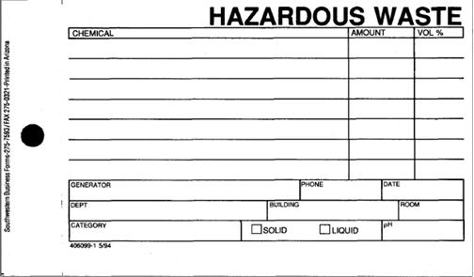
Hazardous Waste – EHS hazardous waste tag for print.

- Hazardous waste generators must ensure that the correct contents and concentrations of chemicals are listed on the hazardous waste tag. The contents must be written in words using the correct IUPAC name or chemical name, not trade names or formulas. Appendix B lists proper IUPAC names. This is a regulatory requirement for accountability and transportation. Please see the properly completed, sample EHS Hazardous Waste Tag illustrated on the following page.

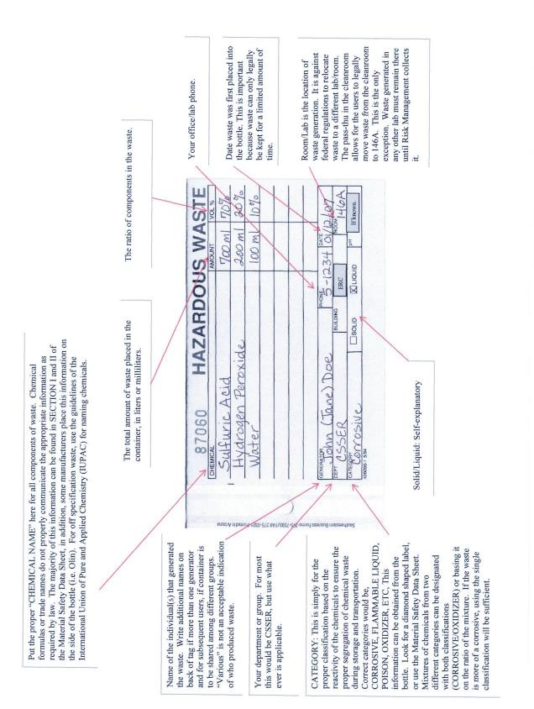
*PROPERLY COMPLETED HAZARDOUS WASTE TAG*

Only one person is allowed per sprayer or per sink at one time. You must clean up and properly dispose of all waste when work is complete.

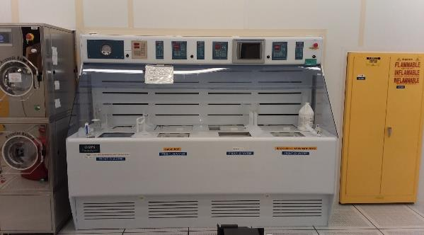
Acid hood, waste bottles and in use chemicals in the back. Note – one sink/one user and one sprayer/one user!

There is to be no storage of raw or hazardous waste chemicals at any workbench except for those immediately needed for the experiment at hand (Please see #4 in this section). No excess equipment (glassware) will be left at workbenches after the conclusion of the experiment or close-of-business.

- Waste chemical bottles are to be removed from the hood and placed in the appropriate waste cabinet at the end of an experiment. It is the individual (waste-generator’s) responsibility to properly complete the Hazardous Waste tag on the waste bottles and place the waste in the appropriate cabinet. Appropriate safety gear must be worn when placing chemicals in the waste cabinets.

- Empty corrosive bottles (acid, base, oxidizer) are to be rinsed three times with water and marked with a permanent marker as ‘rinsed 3X’ by the person emptying the bottle. The first rinse used should be 150ml volume of water, cap the bottle, agitate bottle, and must be collected as hazardous waste if it can not be poured down the drain (i.e. it is an “exotic” waste). Initial rinse waste from several bottles of the same chemical category may be poured into one hazardous waste bottle. The second and third water rinses must fill the bottle completely and may be poured down the drain. All bottle rinses are to be performed in the Cleanroom or other dedicated use laboratories in wet benches approved for the chemical type. It is the user’s responsibility to comply with these procedures.

- Empty solvent bottles do not need to be rinsed, and must be placed in the solvent cabinet and marked as empty.

- Solvent waste (and some mild base and mixed solvent/base waste, e.g. developer, strippers, etc.) can be directly poured into the appropriately labeled waste bottle in the bulk waste bin next to the stainless solvent wet hood in the photo bay. Use the funnel to pour the waste into the appropriately labeled bottle and remove the funnel and recap the bottle when completed.

- For complex chemicals, contact AEP Core staff for proper empty bottle disposal procedures.

- Any and all concerns about the compatibility of chemicals to be stored in waste cabinets should be addressed immediately with AEP Core staff or MTW EH&S (480-727-8956). Incompatible combinations of chemicals pose an unacceptable risk to the health and welfare of people within the AEP Core and the ASU community. Such a violation will be viewed as a criminal act.

Section VII. Chemical Spill Procedures

Note: Rules are shown in Bold Procedures and FYI’s are Italicized

- Small spills (50-100 ml) may be cleaned up by user using a Cleanroom wipe wet with DI water. The wipe should then be disposed of in the appropriate waste container. Wipe the spill area a second time with a wet wipe to ensure all spilled chemical has been removed. Wipe the area with a clean dry wipe until the spill area is dry.

- Large spills (100-1000 ml) “Notify AEP Core staff for assistance”, may be neutralized using Neutracid, spill kit, or materials on spill cart. Spill carts are located in both cleanrooms and are labelled on the building floorplans in the appendix. The neutralized liquid can be cleaned up using the same procedure as for small spills (#1 above). AEP Core staff is to be notified of cleanup materials used so they can be replenished.

- Major spills (greater than 1000ml) must NOT be addressed by individuals. In the event of a major spill, evacuate the area and contact either AEP staff or MTW EH&S. The person involved with the spill must remain nearby until either an AEP Core or EH&S staff member arrives. The person involved with the spill is required to advise others from entering the affected area. If the situation presents an immediate threat to life and safety call 911.

- An Incident Report (see Section III) must be filed with the MTW safety officer (and AEP Core) for all chemical spills within 24 hours. The link to the form can be found at: https://cfo.asu.edu/incident-reporting.

S.W.I.M.

Stop the spill
Warn others
Isolate the area
Make for the exit

- AEP Core staff may opt to handle a major spill. If so, they must use all appropriate safety gear while using the spill cart and/or Neutracid. The residual liquid must be contained and placed into suitable containers for pick-up by EHS. AEP Core staff will be trained in the use of spill kits/carts. Students may also be trained (if desired) in the use of spill kits.

- If AEP Core staff determines the spill is beyond their abilities, MTW EH&S is to be notified immediately (965-1823). AEP Core staff will remain close to the spill to secure the hazardous area until EH&S arrives.

- If an Incident Report (see Section III) has been filed, AEP Core will review the report along with the MTW safety officer and discuss the incident within 72 hours.

Chemical Spill Response
Size | Small | Large | Major
Volume | <100 mL | 100 mL – 1 L | > 1L
Clean up performed by: | User | User with AEP Core Assistance | AEP Core Staff or MTW EH&S. Life threatening spills should be reported to 911
Steps for User/Staff to follow: | - Wet Cleanroom wipe with DI Water | - Select clean-up material appropriate to chemical from Neutracid, spill carts or material on spill carts. | - Evacuate area
 | - Wipe up spill. | - Follow instructions on spill clean-up container | - Contact AEP Core staff or EH&S immediately. Remain nearby, but outside spill area
 | - Repeat Steps 1 and 2. | - Wipe area where spill clean-up material was used with cleanroom wipe wetted with DI water | - Provide information on spill to EH&S and AEP Core staff
 | - Wipe spill area with a dry cleanroom wipe. | - Repeat Step 3 | - Keep other outside of spill area.
 |  | - Wipe spill area dry with Cleanroom wipe
Disposal of Spill Clean-up Materials | Place wipes in appropriate hazardous waste container | Place spill response materials and wipes in appropriate hazardous waste container | EH&S will manage
Incident Report |  | Required, also report use of spill clean up materials. | Required

Users unfamiliar with spill kits/carts should follow procedures for Major Spills. For further information, please contact the Macro Technology Safety Officer at 480-727-8956, or by e-mail at brian.mcnamara@asu.edu. Forms may be found at: https://engineering.asu.edu/safety.
Thank you!

Appendix A: Glossary of Acronyms & Terms

AEP Core | Advanced Electronics and Photonics Core Facility
BOE | Buffered Oxide Etch: Typically, a 10:1 mixture hydrofluoric acid and ammonium fluoride
Buddy-1 | Safety rule requiring 2 people to be present in Cleanroom after normal working hours
Buddy-2 | Safety rule requiring you inform someone of your presence and activity in Core laboratories with chemicals after normal working hours
COB | Close of business: Typically defined as 5PM or 1700 hrs
Cryogenic | Of or relating to low temperatures
EH&S or EHS | Environmental Health and Safety
FAQ | Frequently Asked Questions
Fab or Cleanroom | Semiconductor processing facility located in Rooms 1514, 2206, 2208, 2210, 2305, and 2318
HF | Hydrofluoric Acid
HMDS | Hexamethyldisilazane: used to improve adhesion of photoresist
IUPAC | International Union of Pure and Applied Chemistry
NFPA | National Fire Protection Association
Normal Working Hours | Defined as 8AM – 5PM Monday thru Friday
Pass-thru | The two sided cabinet that connects cleanroom and a room outside of the cleanroom and allows for safe transfer of chemicals back and forth
PHA | Preliminary Hazard Analysis: a written procedure that ensures user understands the nature and hazards of chemicals used in their work
Piranha | A mixture of sulfuric acid and hydrogen peroxide used for wafer cleans
PPE | Personal Protection Equipment such as goggles, gloves, and aprons
“Right-To-Know” | A law requiring information is provided on possible chemical exposure
Safety (safe•ty) | The state of being safe; freedom from the occurrence of risk of injury, danger, or loss; the action of keeping safe.
SDS | Safety Data Sheet (formerly Material Safety Data Sheet or MSDS)
SESHA | Semiconductor Environmental Safety and Health Association
SMBWA | Safety Management By Walking Around
Zephiran | Benzalkonium chloride solution: a treatment for hydrofluoric acid burns

Appendix B: Common and Correct (IUPAC) Chemical Names

Acids
Common/Colloquial Name | Correct (IUPAC) Technical Name
Chrome Etch | Ceric Ammonium Nitrate, Nitric Acid
Piranha Etch | Sulfuric Acid, Hydrogen Peroxide
Gold Etch (TFA & GE) | Potassium Iodide
Nitric | Nitric Acid
Sulfuric | Sulfuric Acid
Peroxide | Hydrogen Peroxide
BOE 10:1 | Hydrofluoric Acid, Ammonium Fluoride
HF | Hydrofluoric Acid
Bases
Common/Colloquial Name | Correct (IUPAC) Technical Name
353 Developer | Sodium Hydroxide
APEC Resist Developer w/ Surfactant | Tetramethylammonium Hydroxide
AZ 300 MIF Developer | Tetramethylammonium Hydroxide
AZ 400K Developer | Potassium Borates
AZ 527 Developer | Tetramethylammonium Hydroxide
OCG 934 Developer | Tetramethylammonium Hydroxide
Potassium Hydroxide (K O H) | Potassium Hydroxide
Ammonium Hydroxide | Ammonium Hydroxide
SRS-100 Resist Strip | 1-Methyl-2-Pyrrolidinone, Tetramethylammonium Hydroxide, Propanediol
EBL Chemicals
Common/Colloquial Name | Correct (IUPAC) Technical Name
PMMA | Polymethyl methacrylate
MIBK | Methyl Isobutyl Ketone
CS | 2-Ethoxyethanol
MEK | Methyl Ethyl Ketone
Methanol | Methyl Alcohol
Ethanol | Ethanol
Isopropanol | Isopropanol
Chlorobenzene | Chlorobenzene
Anisole | Anisole
ZDMAC | N,N-Dimethylacetamide
ZED-N50 | n-Amyl Acetate

Solvents
Common/Colloquial Name | Correct (IUPAC) Technical Name
Acetone | Acetone
IPA | Isopropyl Alcohol
Methanol | Methyl Alcohol
T1100 Rinse Solvent | Mesitylene
XP SU-8 Developer | 1-Methoxy-2-propyl Acetate
QZ 3322 Polyimide Stripper | Ethanolamine, Tetrahydrofurfuryl Alcohol
Nano Remover PG (NMP) | n-Methyl Pyrrolidinone
HMDS | Hexamethyldisilazane
AP 3000 Adhesion Promoter | 1-Methoxy-2-Propanol
DS 3000 Advanced Developer | Triisopropyl benzene
QZ 3501 Polyimide Developer | Dihydrofuranone, Butyl Acetate
Microstrip 2001 Photoresist Stripper | 2-(2-Aminoethoxy) ethanol, n-Methyl Pyrrilidone
AZ 4620 Positive Photoresist | Propylene Glycol Monomethyl Ether Acetate, 1-Methoxy- 2-Propyl Acetate, Cresol Novalac Resin, Diazonaphthoquinone Sulfonic Ester
OCG 825 Positive Photoresist | Ethyl-3-Ethoxypropionate, Novolac Resin, Methacrylic Methacrylate Copolymer, Naphthoquinone Diazide Esters, Trisubstitiuted Benzene Sulfonic Acid Derivative
AZ 5214 E Photoresist | Propylene Glycol Monomethyl Ether Acetate, 1-Methoxy- 2-Propanol Acetate
AZ 1512 Positive Photoresist | 1-Methoxy-2-Propanol Acetate, Diazonaphthoquinonesulfonic ester, Cresol novak resin
AZ 3312 Positive Photoresist | 1-Methoxy-2-Propanol Acetate, Ethyl lactate, Diazonaphthoquinonesulfonic ester
AZ 1505 Positive Photoresist | 1-Methoxy-2-Propanol Acetate
AZ 4330 Positive Photoresist | 1-Methoxy-2-Propanol Acetate, Cresol-novolak resin, Diazonaphthoquinonesulfone
SU-8 Series Resist | Gamma Butyrolactone, Epoxy resin

Appendix C: Cleanroom and Building Floor Plans with Escape Routes and Equipment
First Floor Cleanroom in “Area 5”, the southeast corner of the MTW building

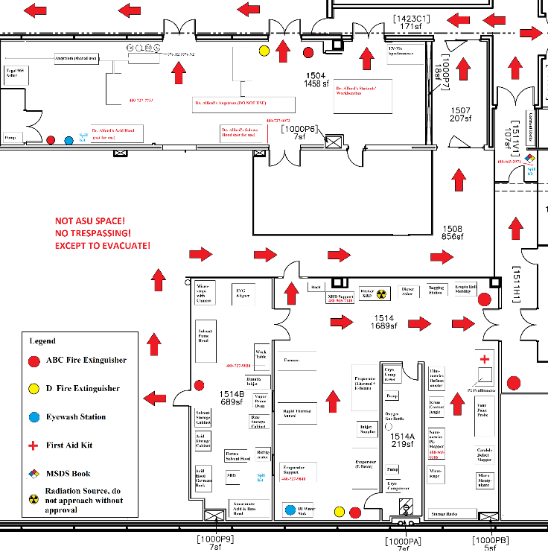
The Red Arrows Indicate Potential Escape Route

Area 3 (South Half of 2nd Floor Cleanroom) Floorplan
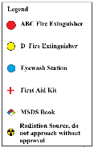
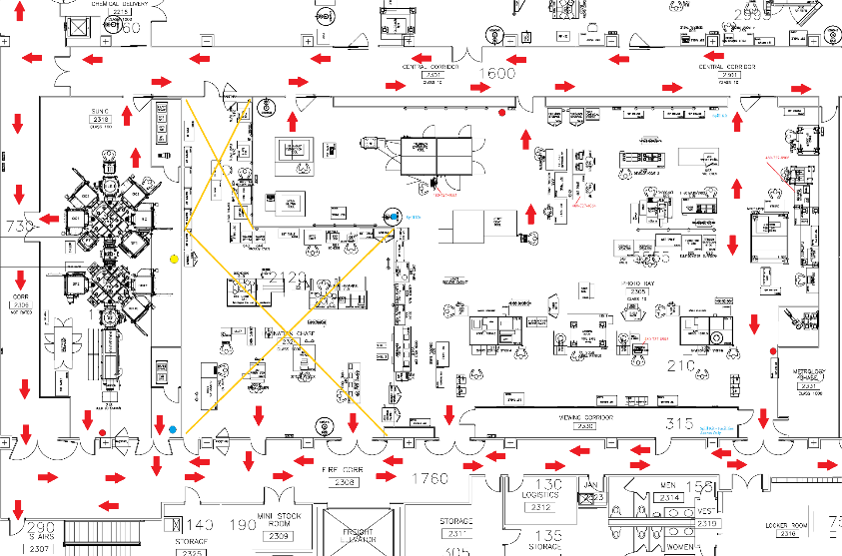
The Yellow “X” Area is off limits due to Construction
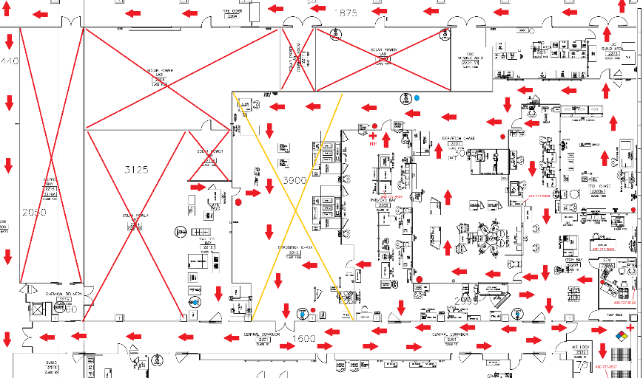
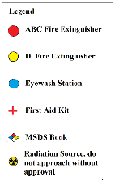
Area 2 (North Half of 2nd Floor Cleanroom)
The Red “X” Areas do not Belong to AEP Core. Do not enter!
The Yellow “X” Areas are under construction. Do not enter except to escape!
Main Building Escape Routes for the Two Cleanrooms and the MTW offices
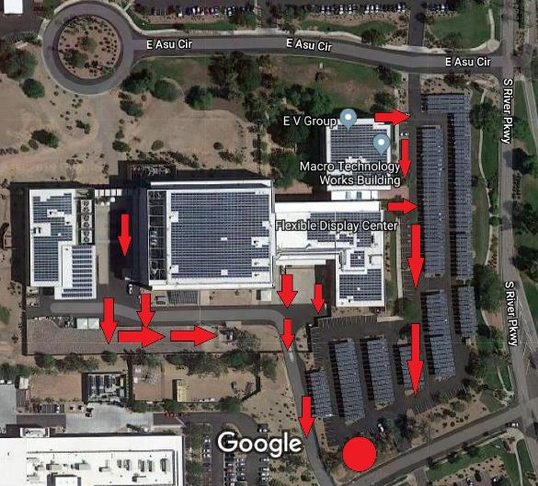

Assemble at the large red circle in the drawing above. The large circle is at the south end of the parking lot beyond the covered parking.

Appendix D: Sample PHA/Chemical Approval Form
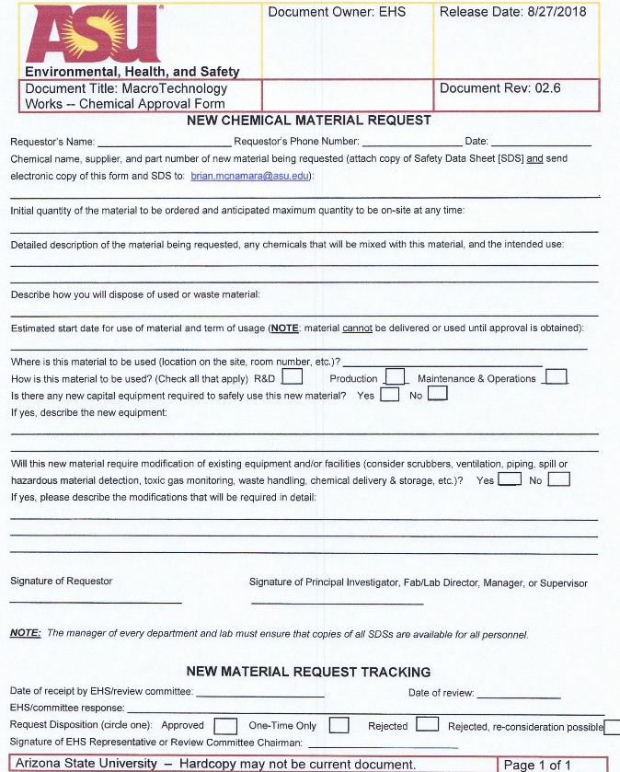

Appendix E: Safety Photographs

Emergency Safety Equipment (HF Medical Kit, Safety Shower and Eye Wash Station, and Spill Kit)
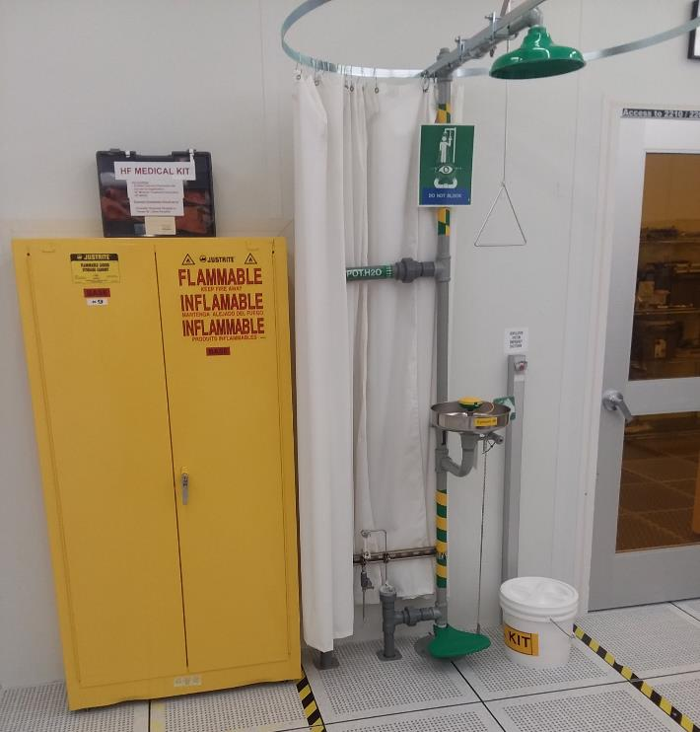

Spill Cart Kit

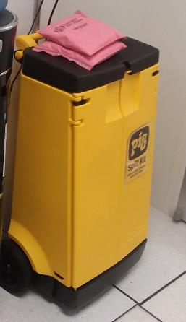

Class ABC Fire Extinguisher, the most common type found in the cleanroom, usually mounted near a door
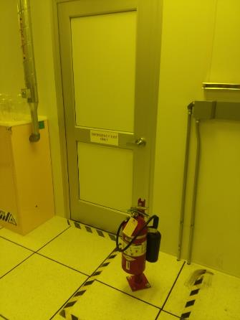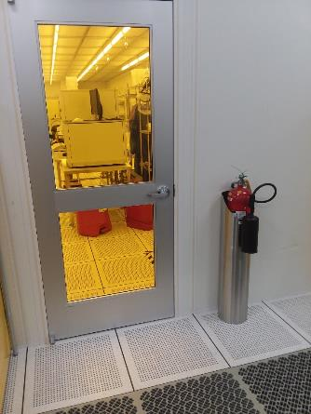

Class D Fire Extinguisher for Combustible Metal, Usually Mounted within 10 Feet of an Evaporator.

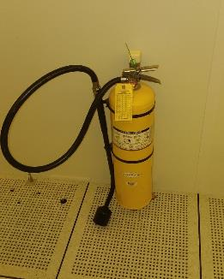
Note the Yellow color. All MTW Class D Extinguishers will be Yellow.

Solvent Hoods
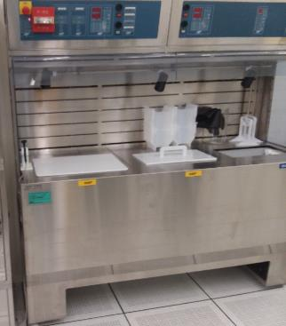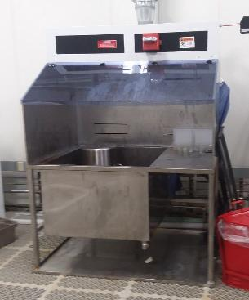 (Left) Currently Marked and Setup for NMP Processing, (Right) For Cleaning and other Processing

Solvent Cabinet for Chemical Storage (Left) Red Solvent and Silver General Waste Bins (Right)
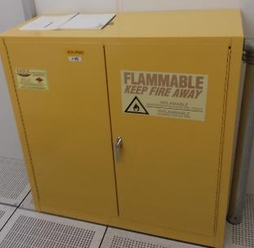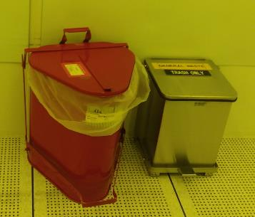
Dry Solvent Waste Only in the Solvent Waste, No Hazardous Waste in the General Waste

Compressed Gas Bottle Dolly
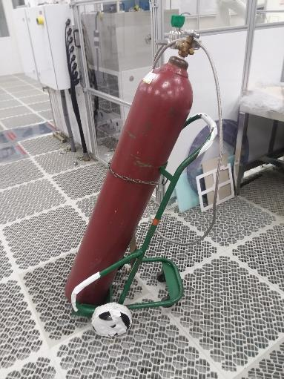
Note: Bottle is secured with chain.

Appendix G: NFPA Hazard Diamond

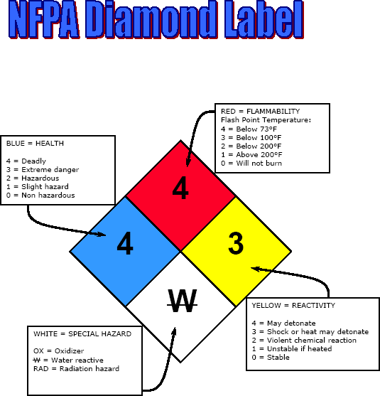

AEP Core Policies and Procedures Handbook Record of Changes

Rev | Date | Changed By | Sections Modified
NC | 12/31/2019 | Team | Initial release of new format. All sections modified.

